**use case diagram**.- is a sequence of steps performed by the user interacting with the system to achieve a goal.

* **Use cases:** Horizontally shaped ovals that represent the different uses that a user might have.
* **Actors:** Stick figures that represent the people actually employing the use cases.
* **Associations:** A line between actors and use cases. In complex diagrams, it is important to know which actors are associated with which use cases.

**class diagram** tells the posible objects the project will have it. -- describes the structure of a system by showing the system's classes, their attributes, operations (or methods),

and the relationships among objects.

**sequence diagram** depicts interaction between objects in a sequence order in a single flow of case use. -- how the clases interac in a specific operation

**association and dependency** represents object can be conected with other objects in the system.

Association indicated a 'has a' and it is a permanent relation, it indicates A keeps a reference to B. Java would be A has an attribute of B type

Dependency is a temporary relationship. A does not keep a reference to B, A only uses B. Sample java should be static methods. Int x = Math.sqrt(9));

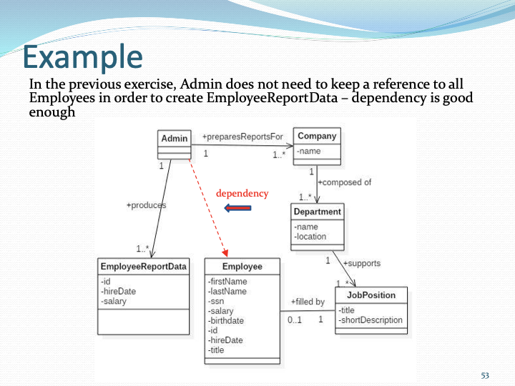

**Which way is best – properties as *attributes* or *associations*?**

When a property has an internal structure, with its own properties, model it as an association; otherwise, as an attribute.

**Rules concerning 1-many associations**

**Unidiractional – 1-1.-** Object A has exactly one object B. It is posible natigate from A to B but no from B to A. Object B must be created as an atribute of Object A.

**Unidiractional – 1- 0..1.-** Object A has zero or one Object B. It is possible navigate from A to B but not from B to A. Object A has property of object B that may be populated.

**Unidirectional – 1- 0..*.-** Object A has zero or more Object B. Object A has a collection empty or not of Object B. It is not possible create Object B independent of Object A.

**Bidirectional – 1 –1.-** Object A has exactly one object B. It is posible natigate from A to B and from B to A. Object B must be created as an atribute of Object A and Object B contains a reference to Object A.

**Bidirectional – 1 – 0..*.-** Object A has zero or more Object B and each Object B has reference to Object A. Object A has a collection empty or not of Object B. It is not possible create Object B independent of Object A.

**Agregation and composition** is a type of association that represents a objects can 'own' another class

Agregation a child could live without a parent.

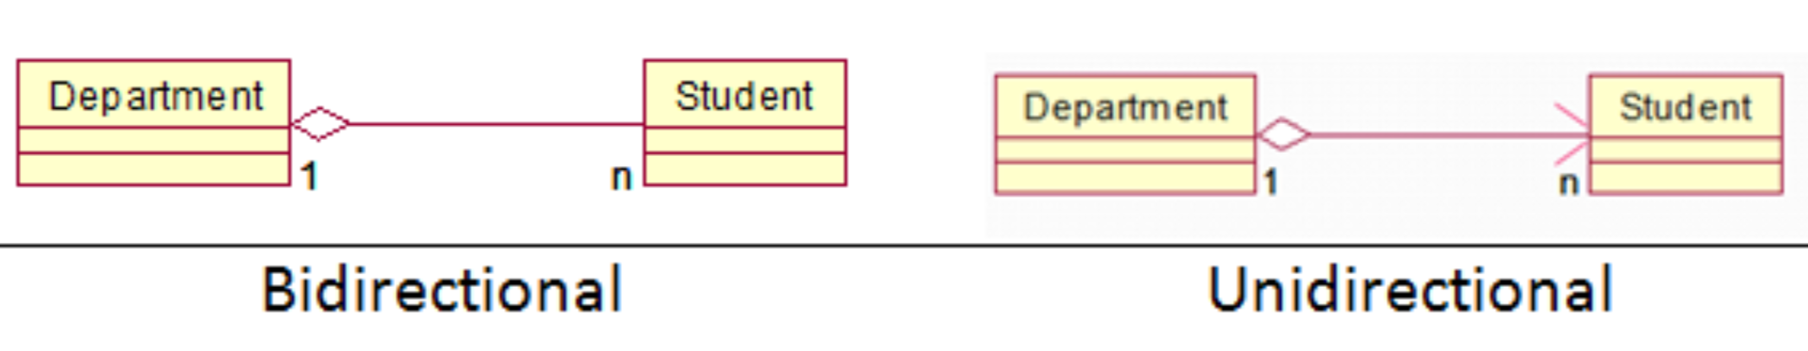

composition if the parent dies the child dies too

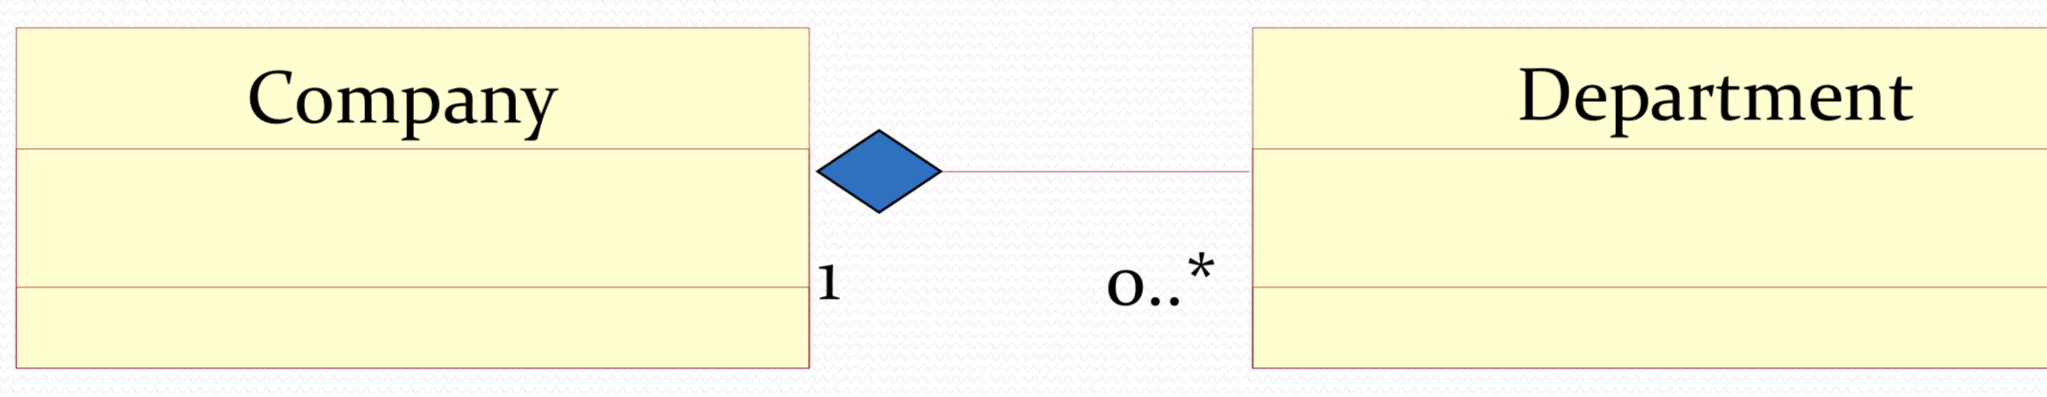

**Reflexive association** indicated relationships between objects of the same class

**Inheritance and composition.-** Generalization (Inheritance) is associated with [inheritance](https://pediaa.com/what-is-the-difference-between-inheritance-and-composition/#Inheritance), which is the process of allowing classes to use the properties and methods of already existing classes. It depects a 'is a' criterion.

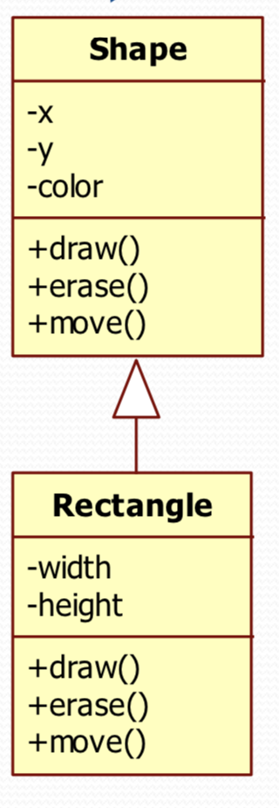

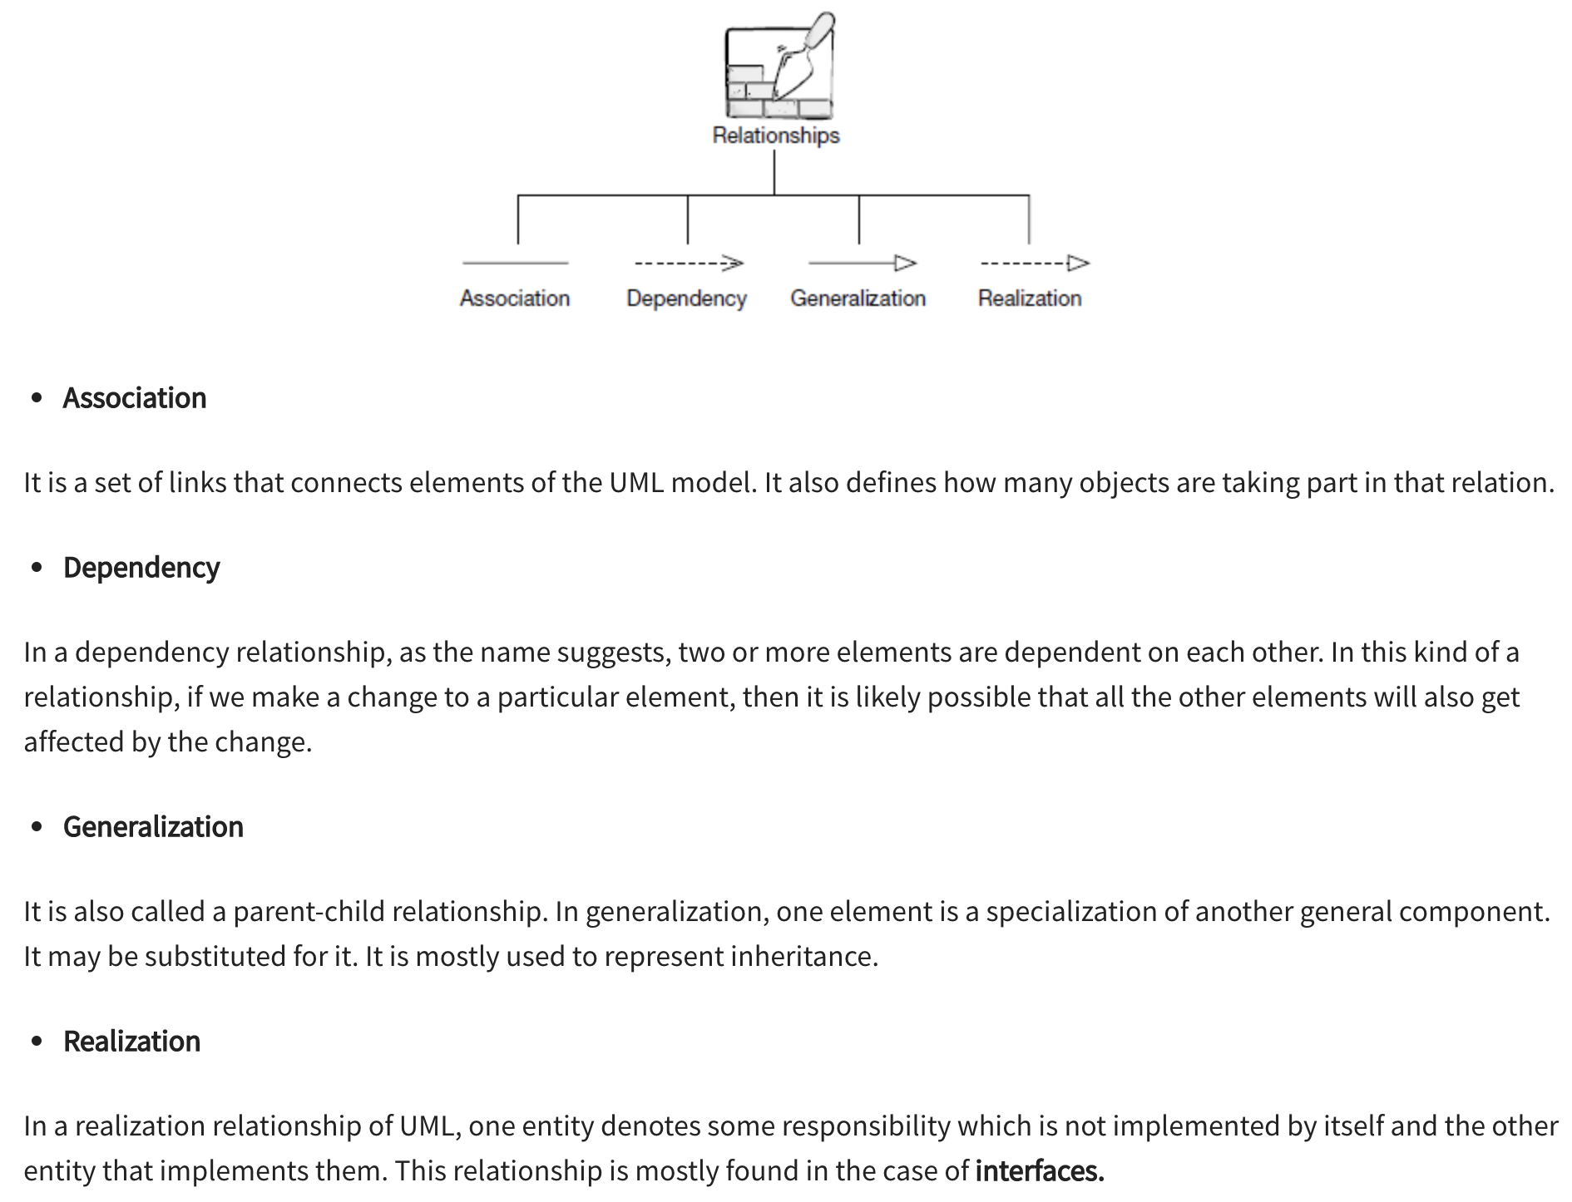

**Sequence diagram**

*Representing Objects in UML.* Diagrams also show proper UML syntax for indicating objects along the top. The syntax is: *instanceName:className*

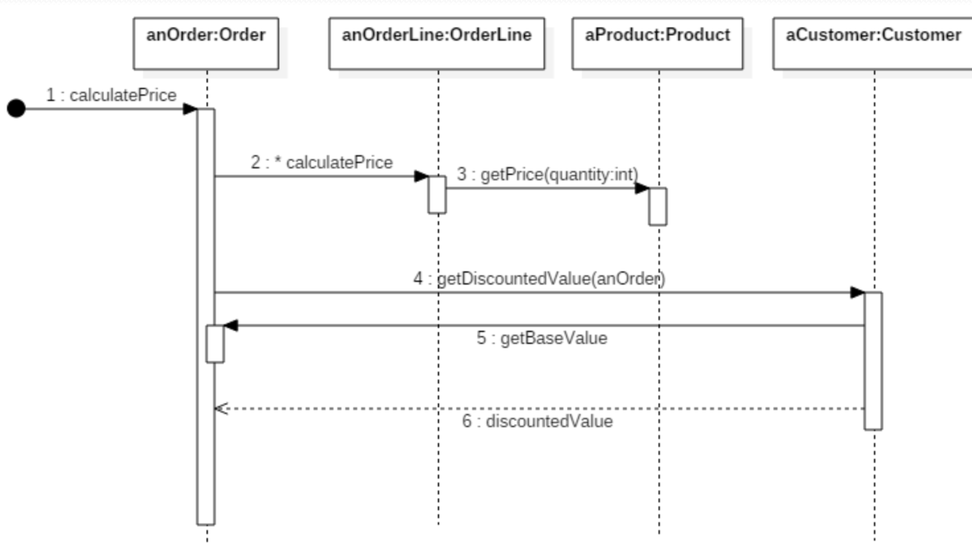

**delegation**. An individual object only works with its own properties – acts only on what it knows – and then asks related objects to do what they know.

**Poliphormys**

**Why do we want polymorphism?**

It allows us to **extend** our program with new features without **changing** existing (already tested) code.

**Late binding.-** when the object type is determined at run time.

A subclass overrides the method of the super class and during execution, methods get associated with their respective references.

It may be noted here that that for Dynamic Binding to occur, it is imperative that the method to be overridden is not declared as static, final or private. Declaring the method with any of the above modifiers will prevent it from being overridden and java will resort to static binding as it can easily determine the parent reference.

Animal a=**new** Dog();

a.eat();

**Early binding-** when the object type is determined at compiler time. Static, private, final methods are bound to the correct method body at compile time – this is called *early binding*

**Template Method Pattern .-** Template method defines the steps to execute an algorithm and it can provide default implementation that might be common for all or some of the subclasses.

When the super class has to define the steps of execution. This order is common for all or some the subclasses

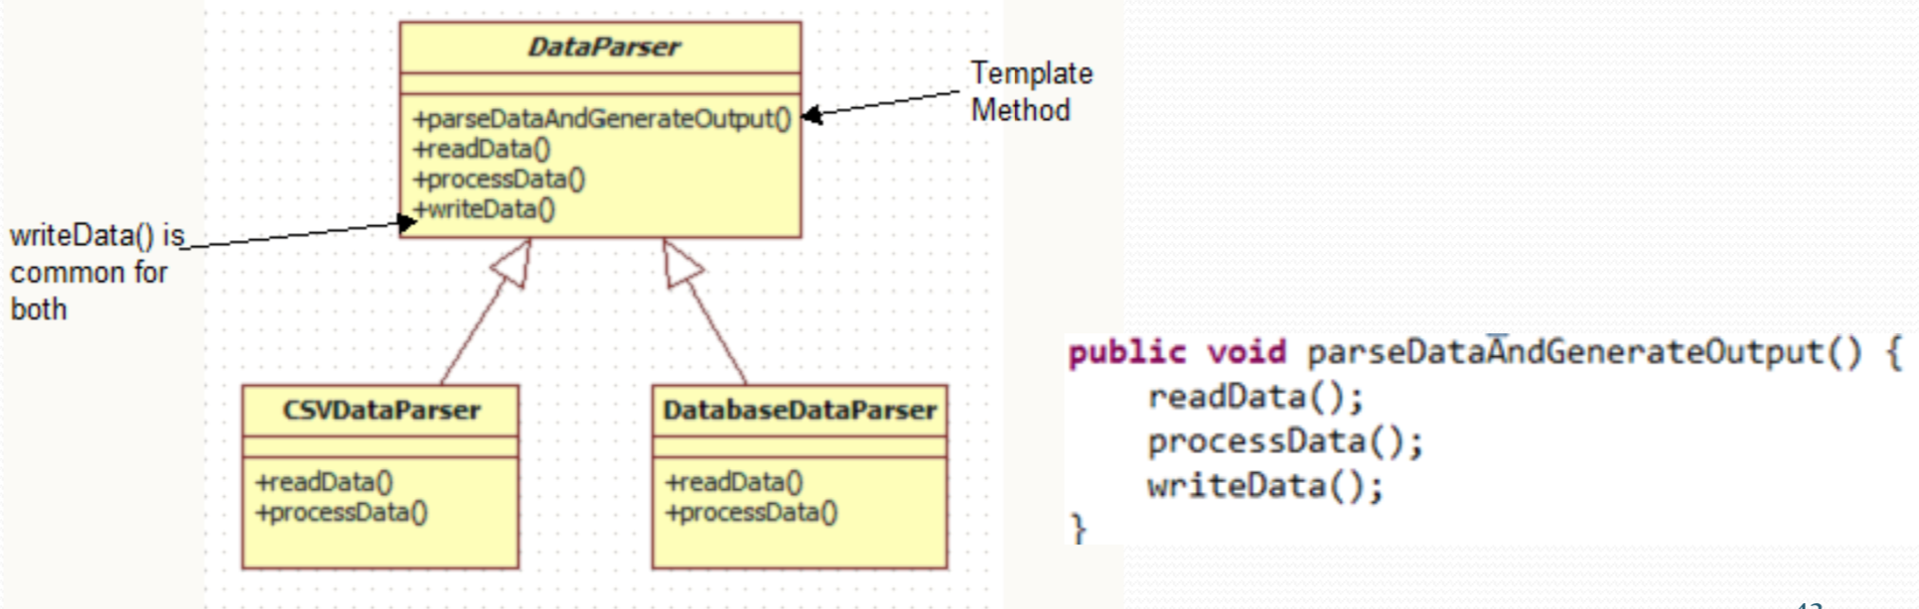

# **Open Closed Principle.-** a project could be open for extention but close for modification

**Interface.-**

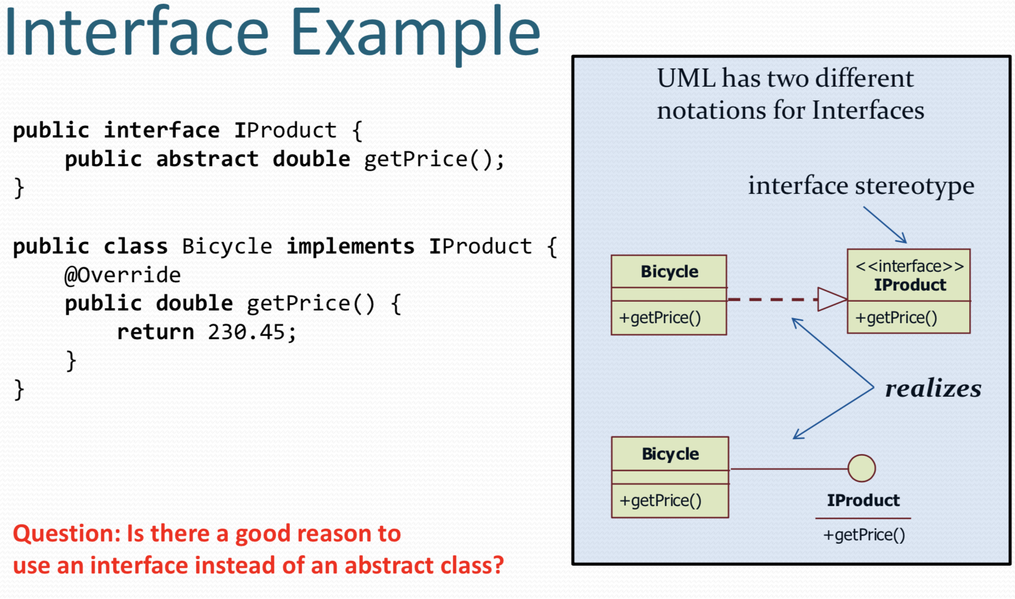

**In Factory pattern**, we create object without exposing the creation logic to the client and refer to newly created object using a common interface.

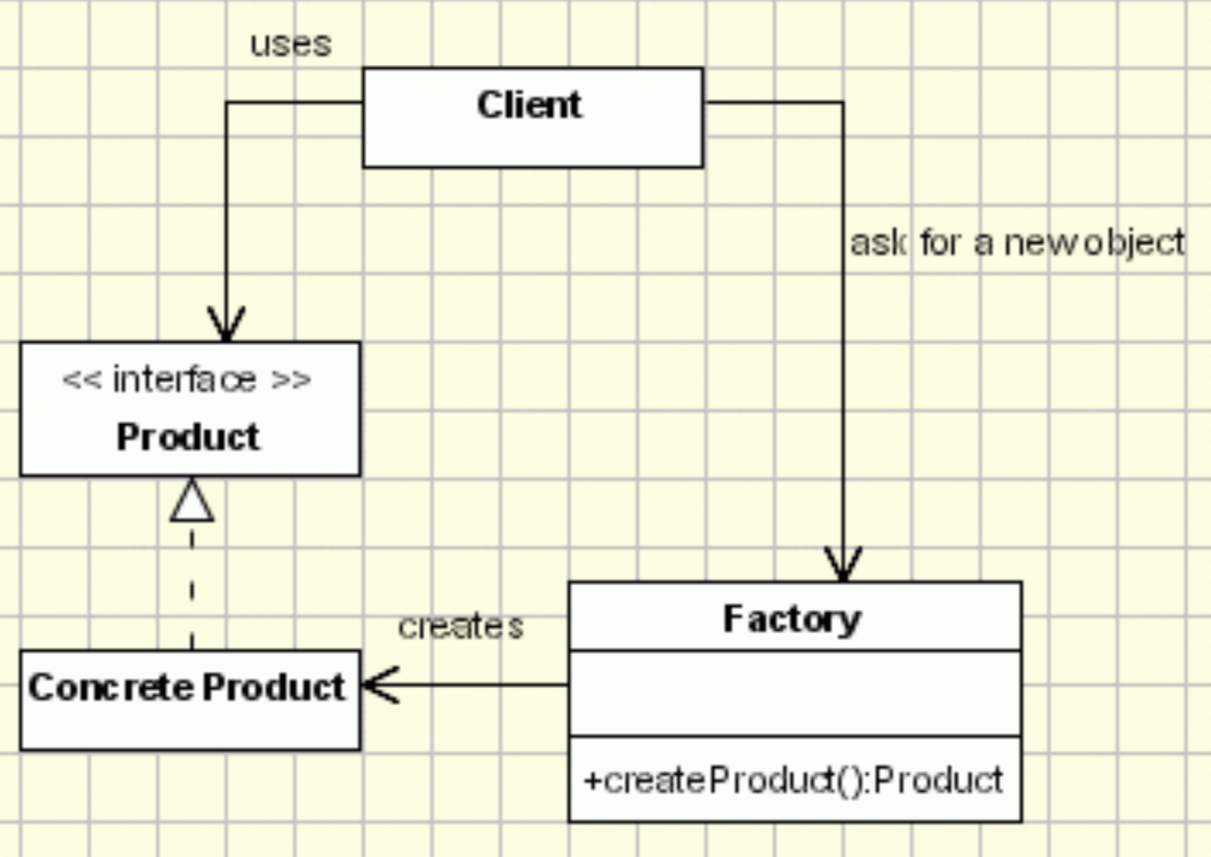

------------------------------------------------------------------------

JAVAFX

Exercices: open a second screen, change color background, event click dropdwon, add menus(menuBar), pass data between screen, export and run in JAR(to export we need to chabge in "Run Configuration", we have to put a nane and indicate the main class, the we export the project as JAR and select the name of the Run Configuration)

Lesson7:

Enum could have two constructor

Error for (Object obj : list){

Obj.toString(); error PROBAR

}

Exercise create class and implement Interator

lesson7.lecture.defaultmethods

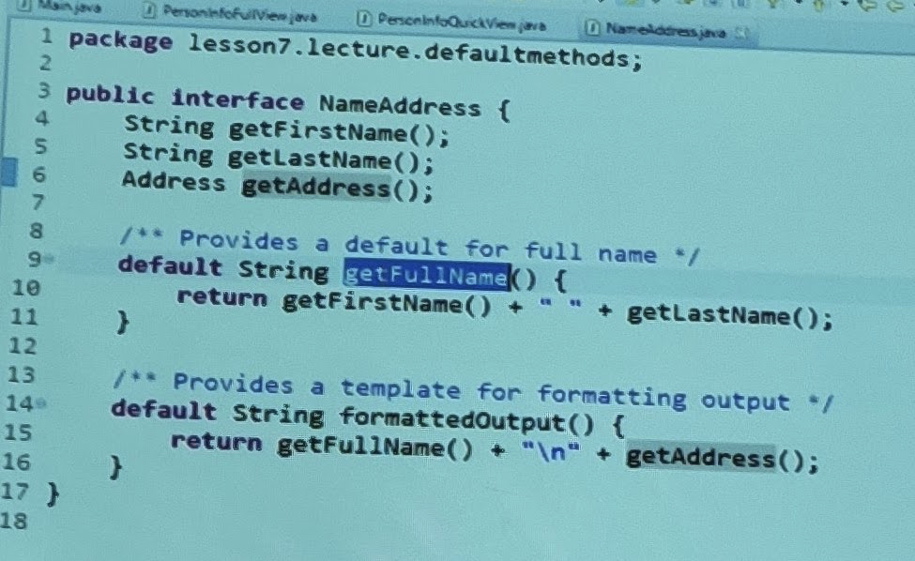

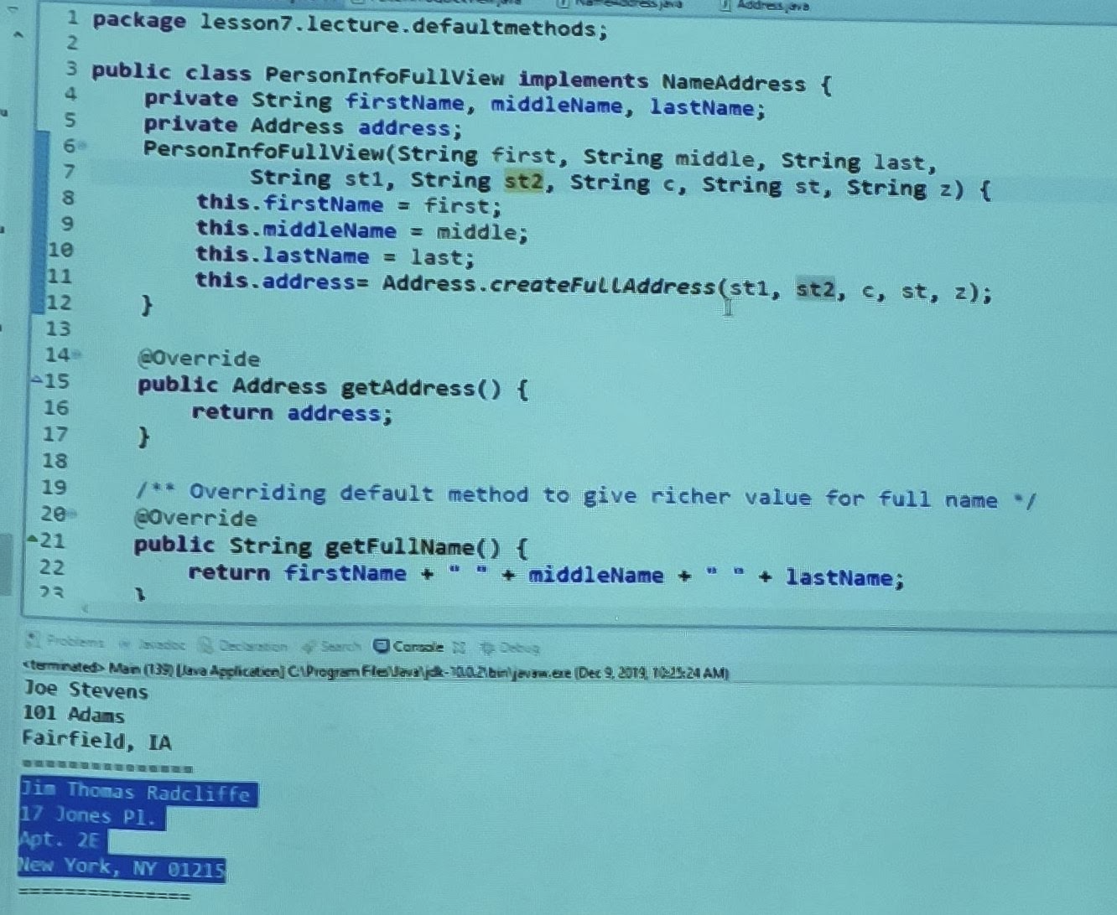

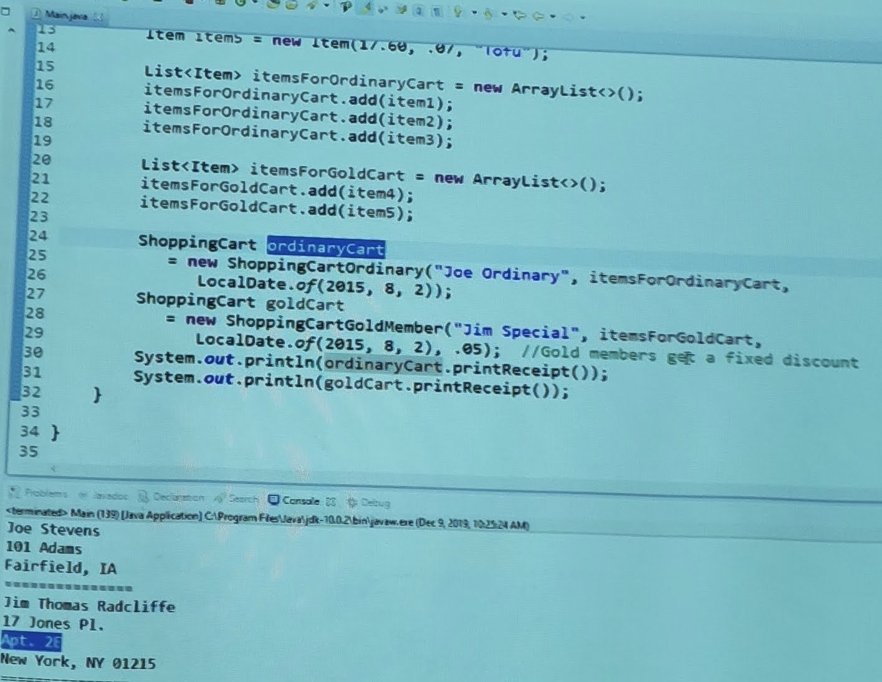

lesson7.lecture.interfacestatic

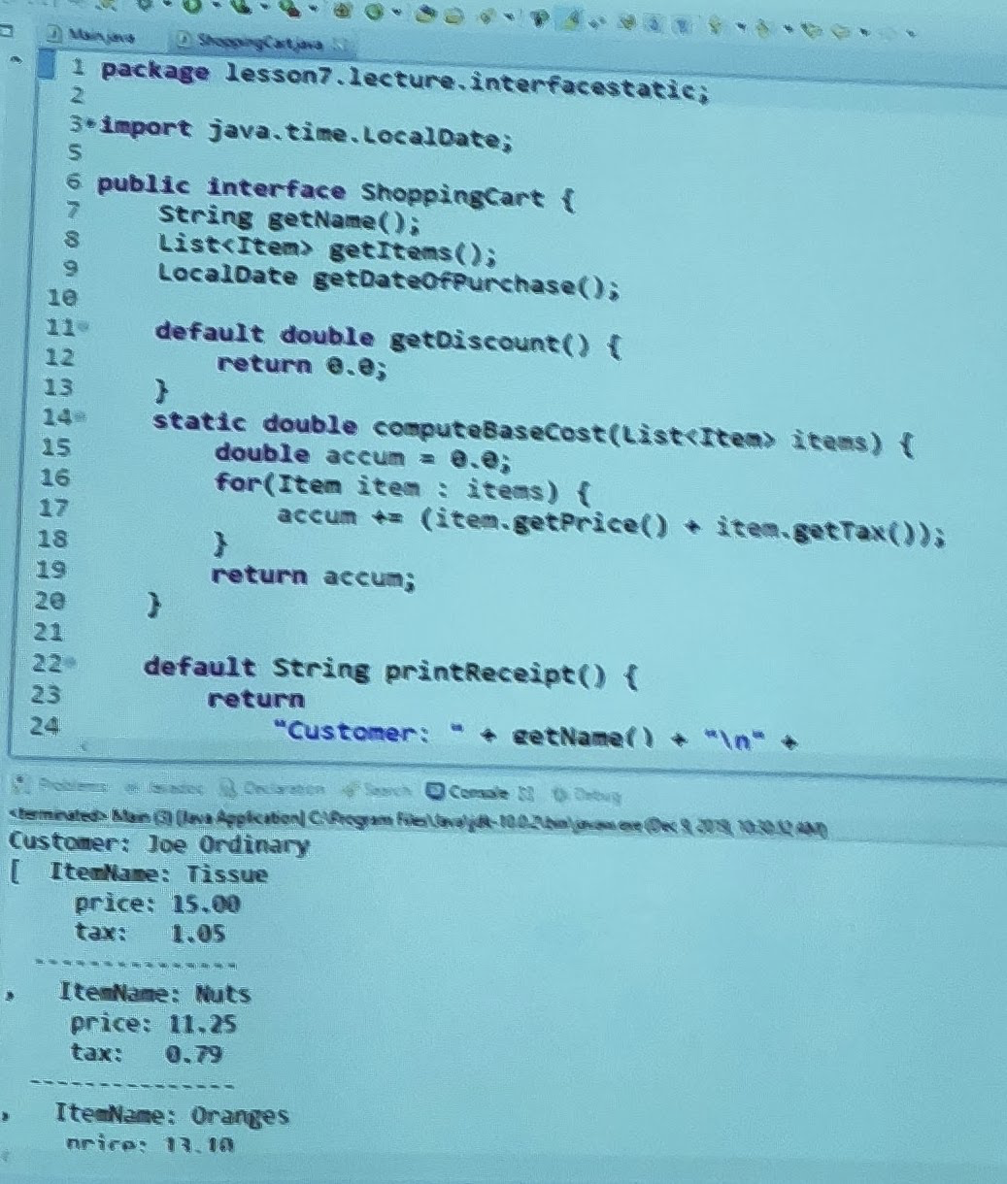

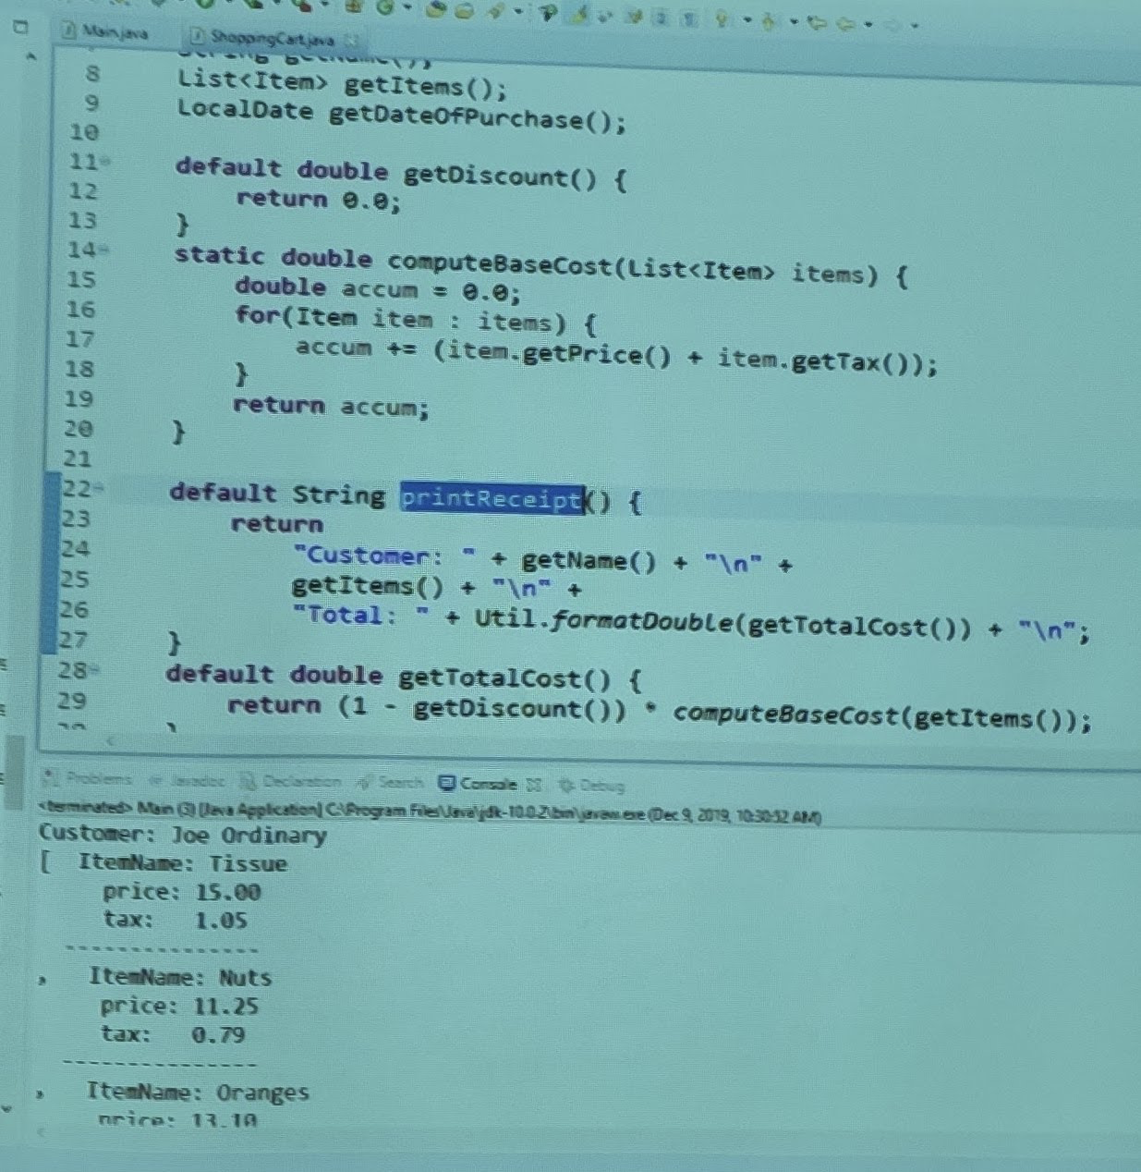

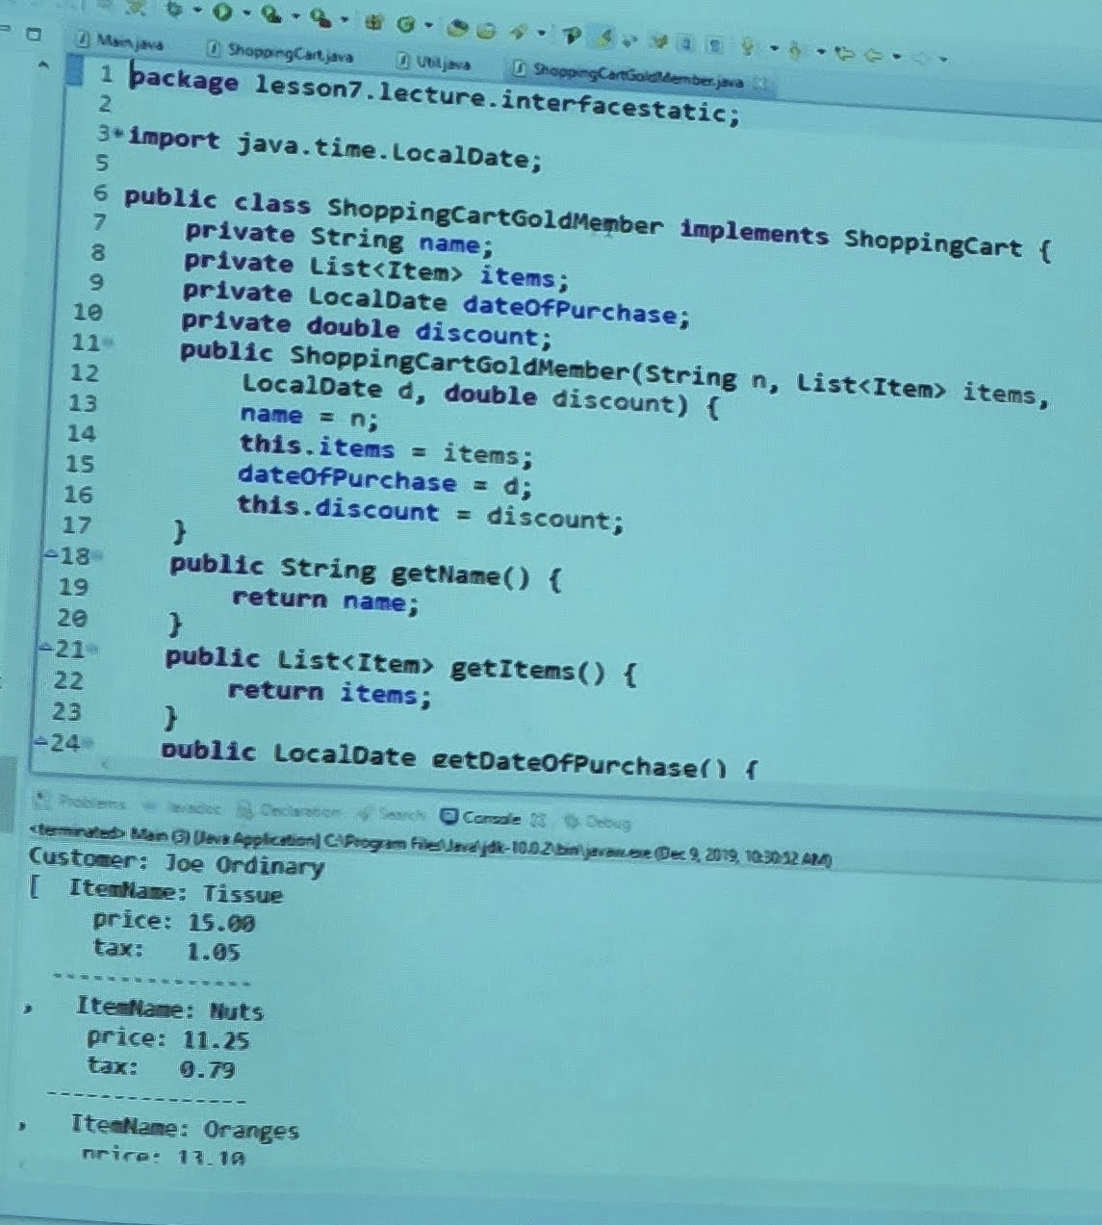

Exercise 7.1 Explore the package exercise7_1 in the InClass Exercises project

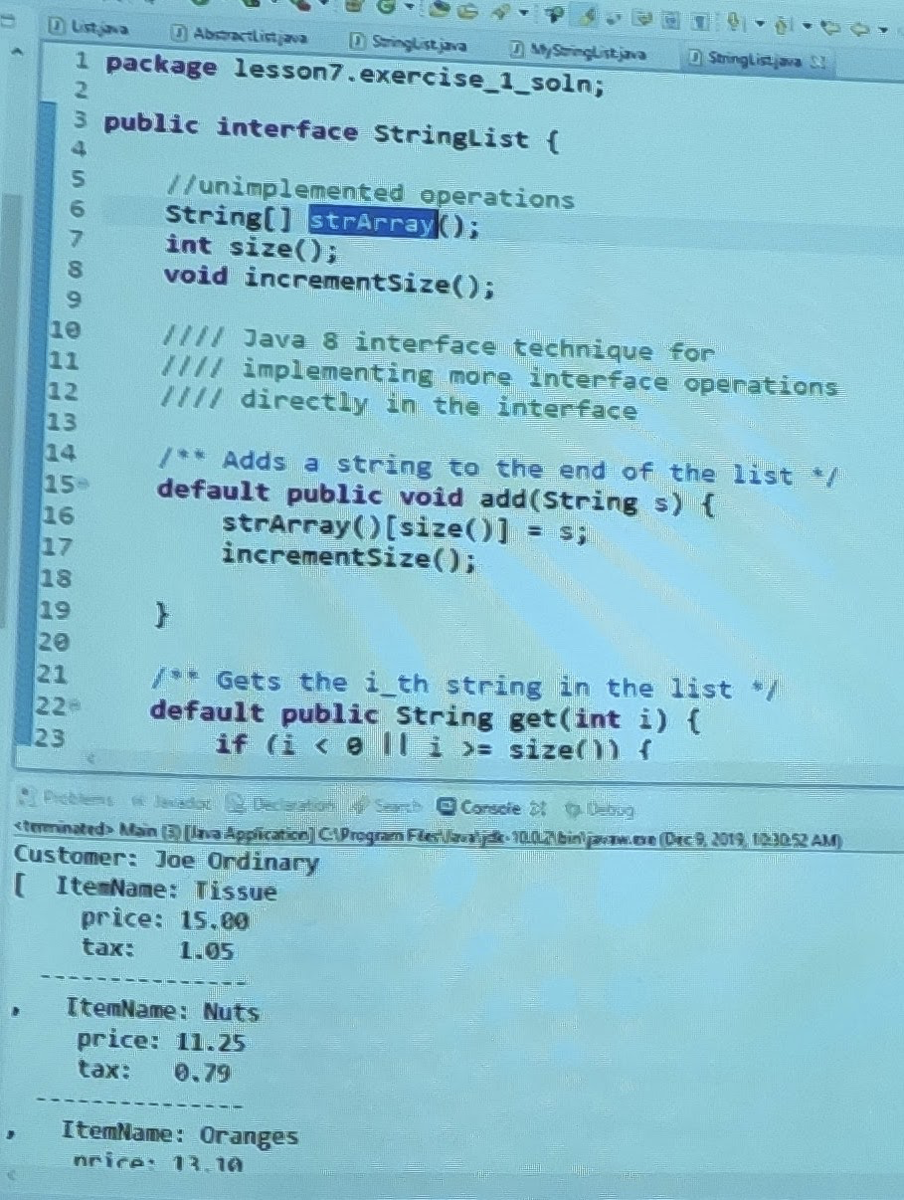

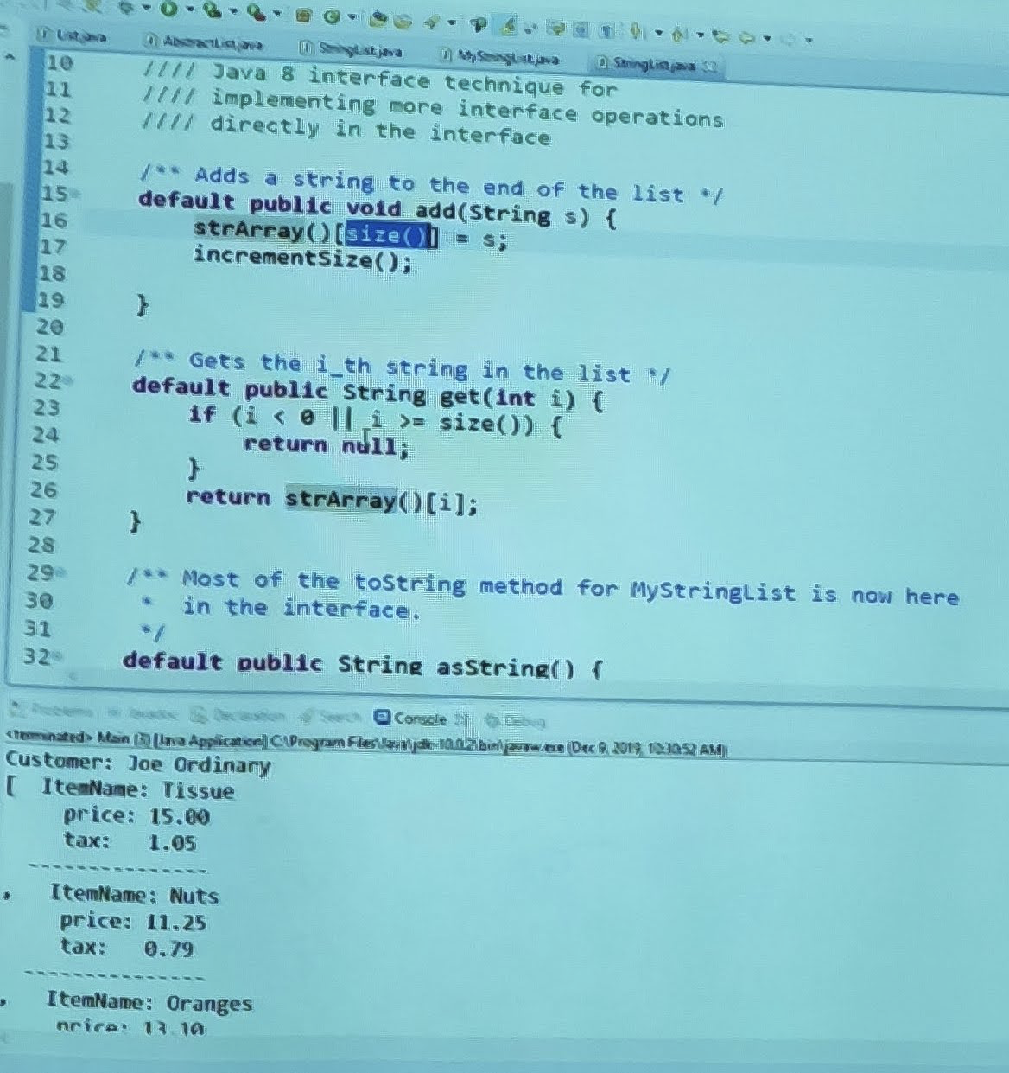

lesson7.lecture.enums.

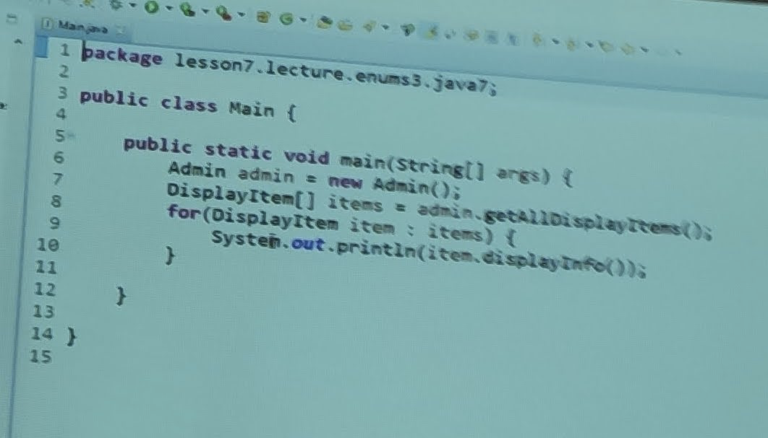

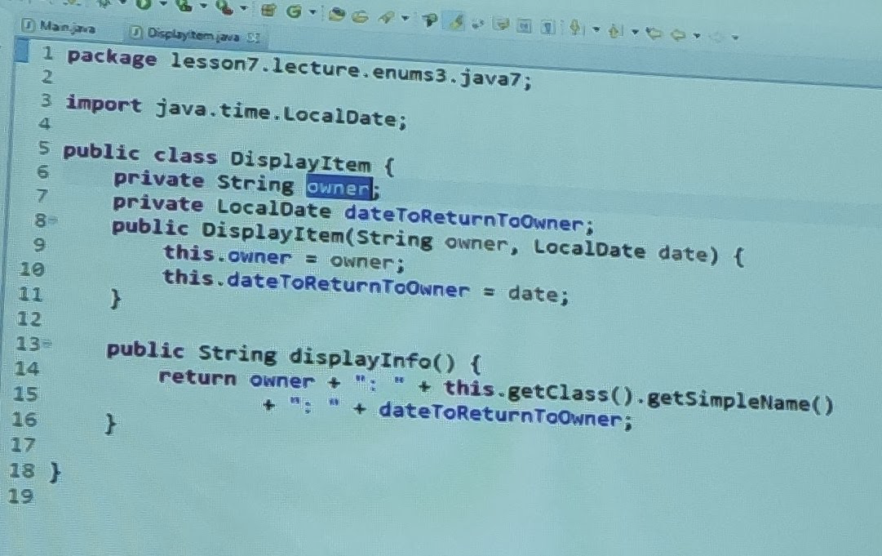

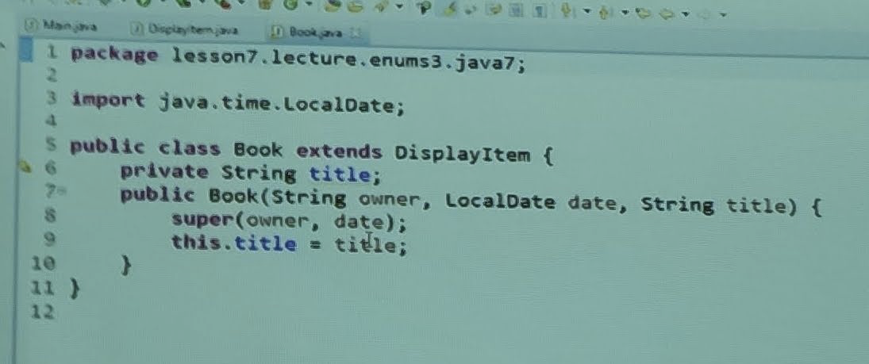

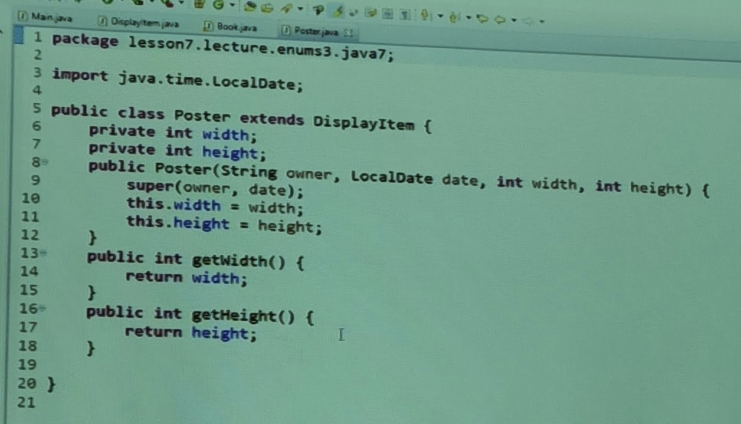

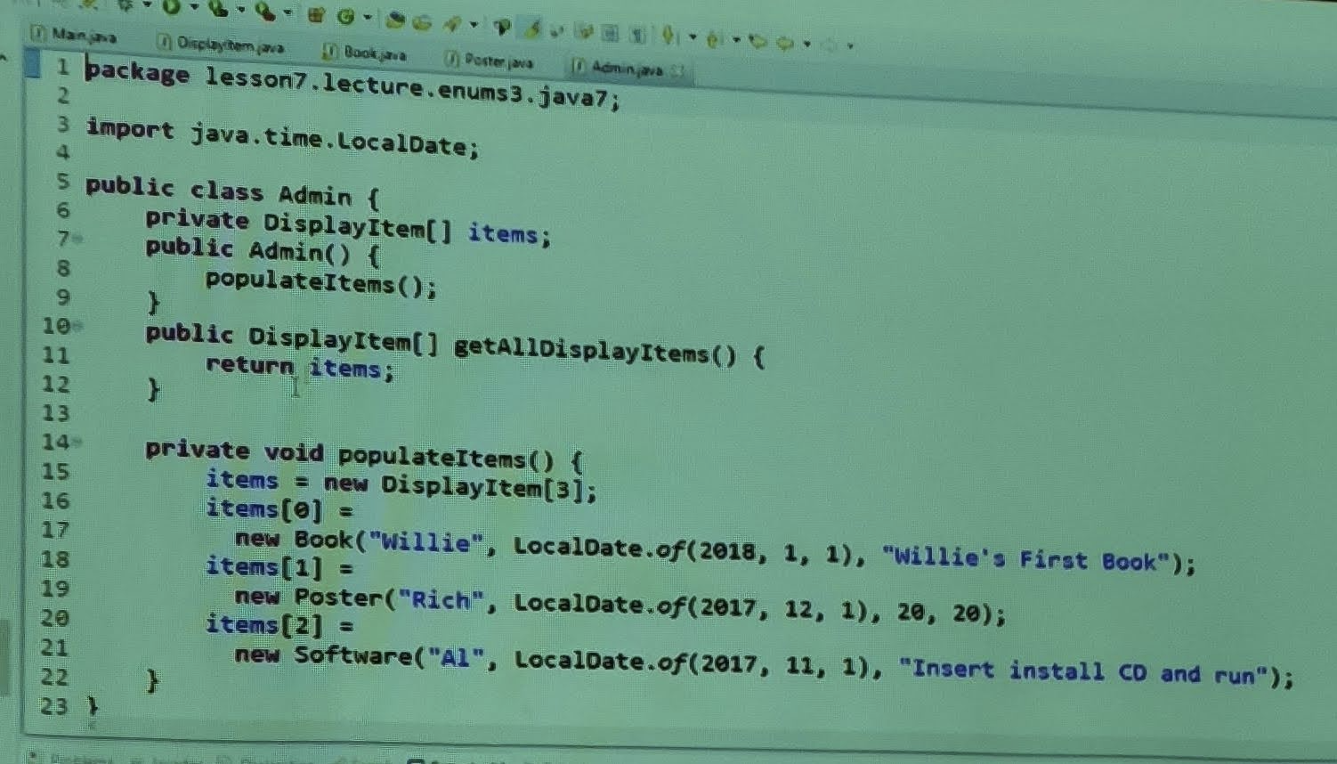

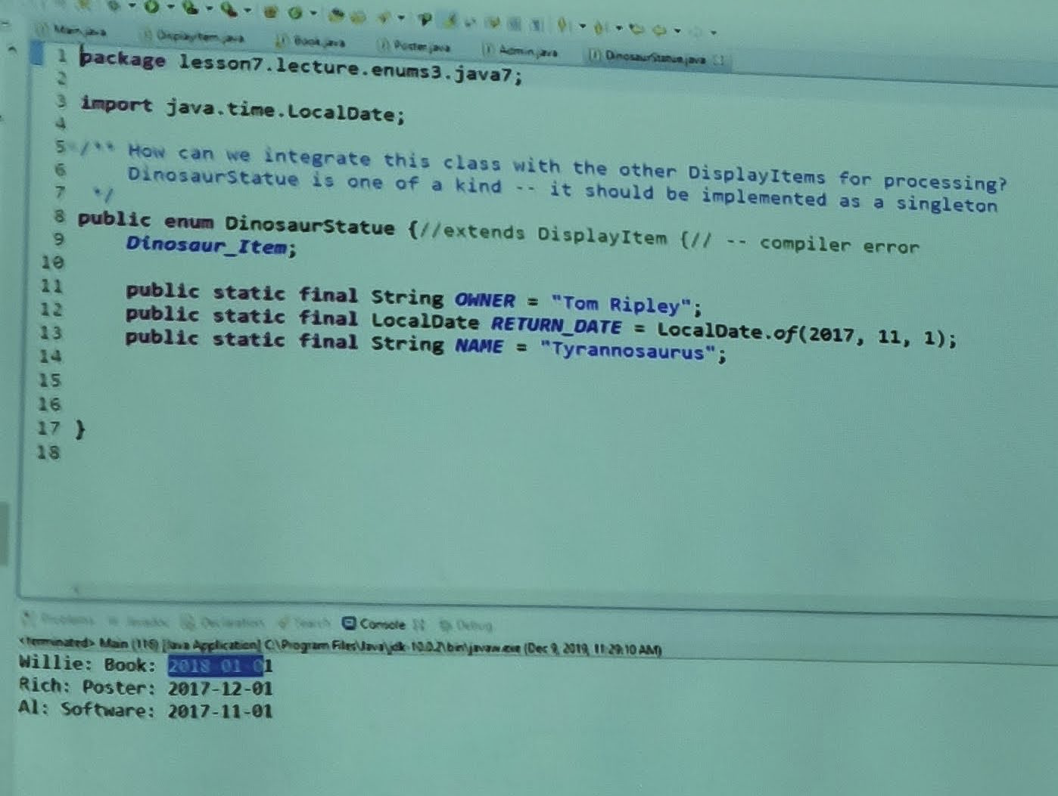

lesson7.lecture.enums3.java7

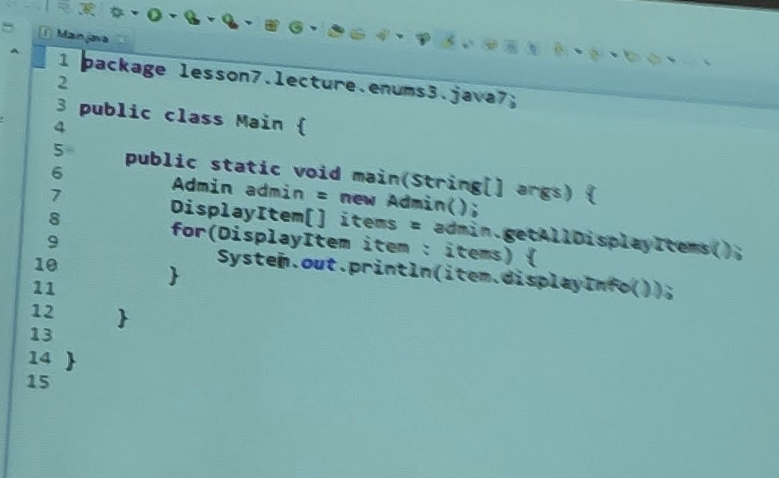

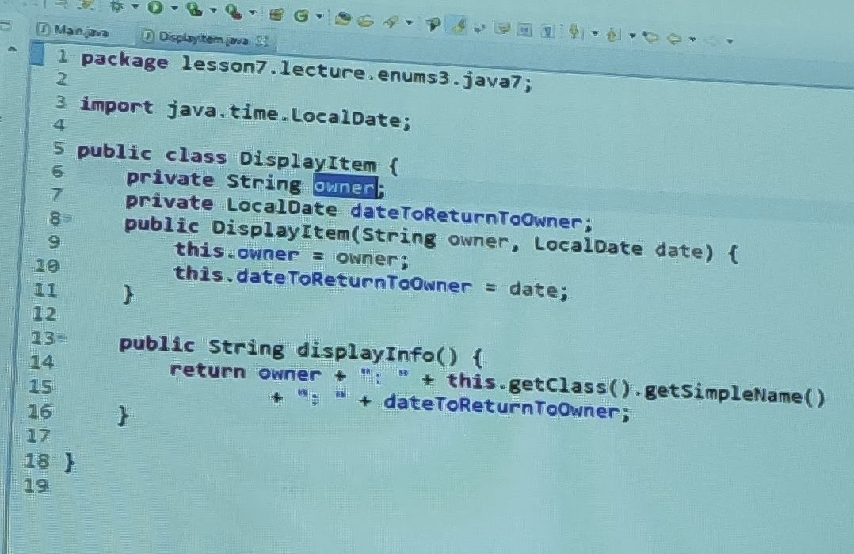

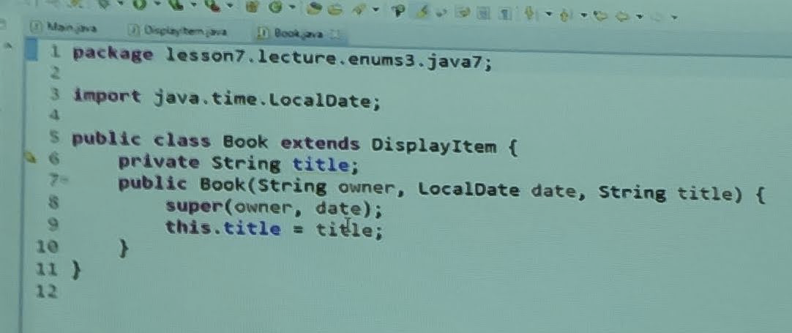

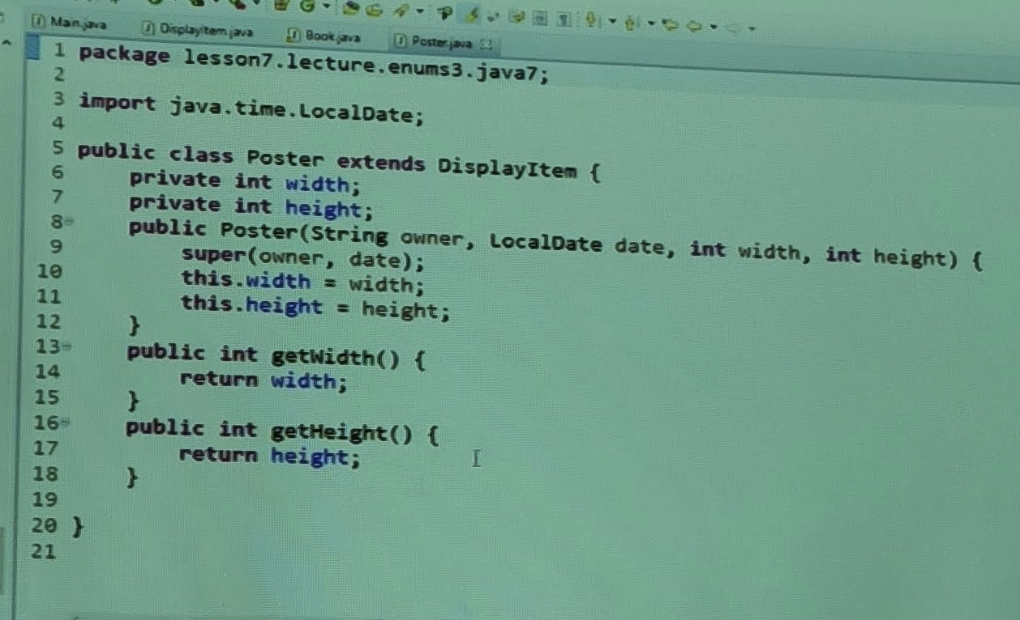

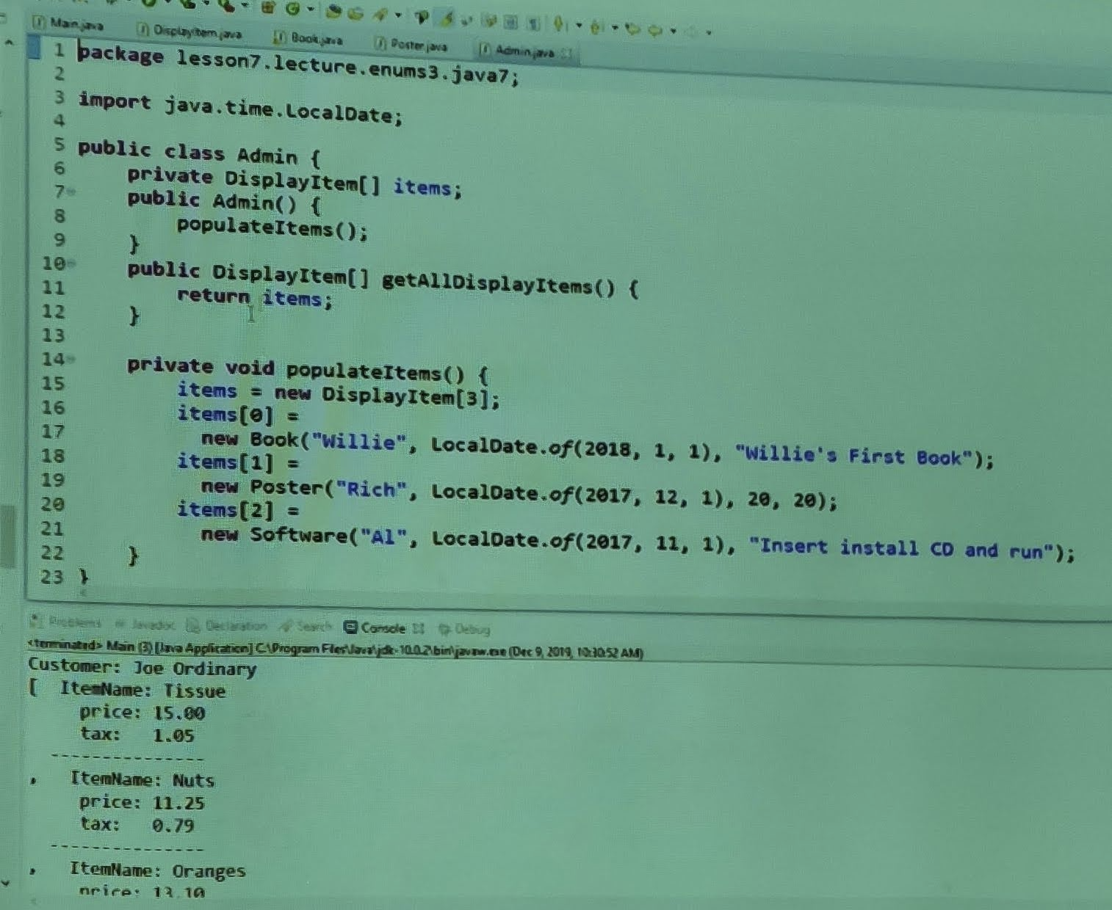

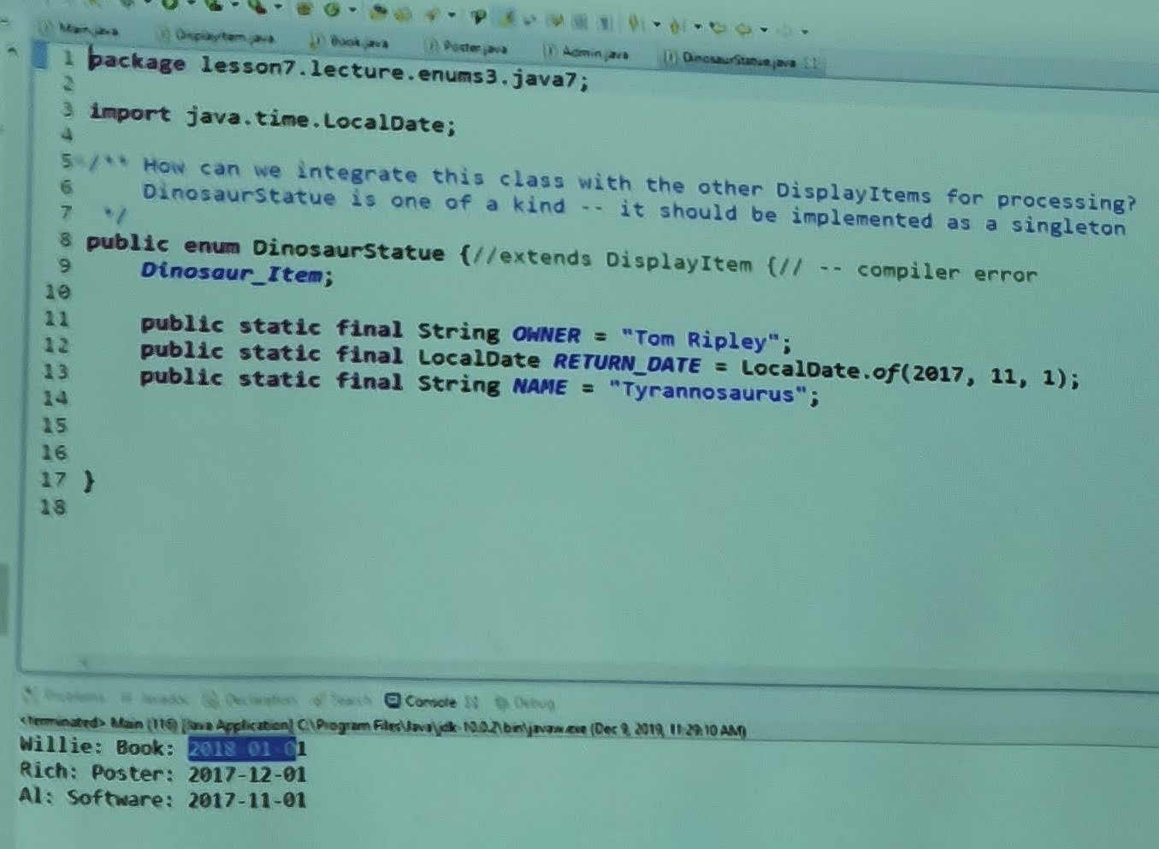

lesson7.lecture.enums3.java8

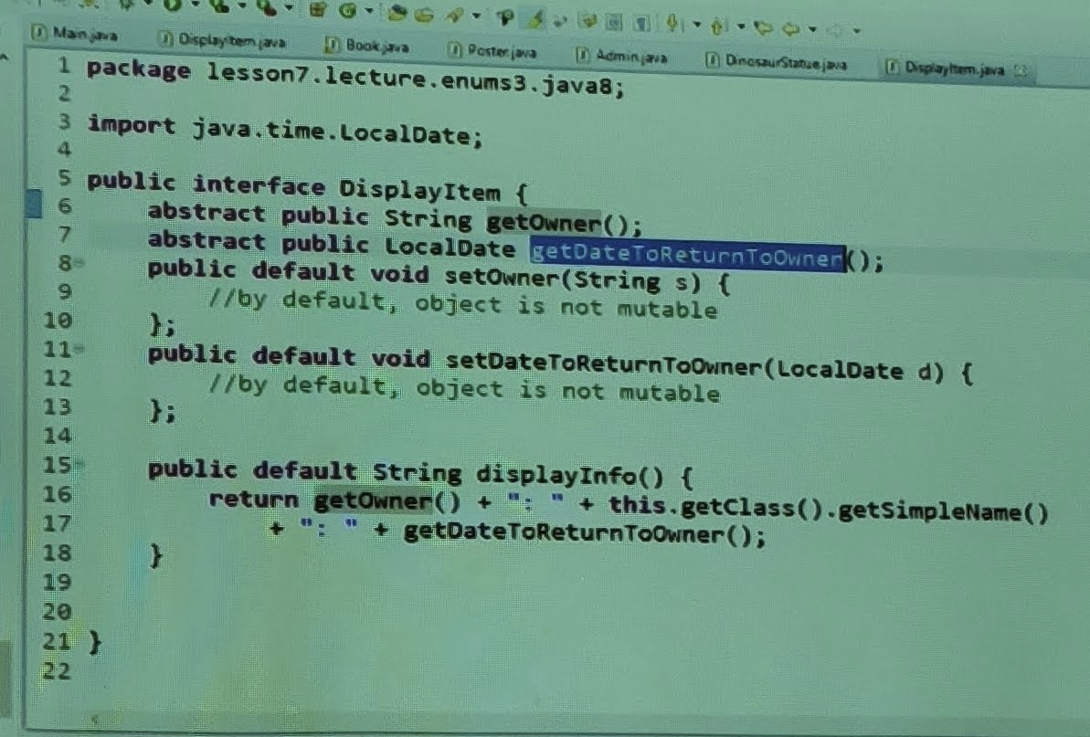

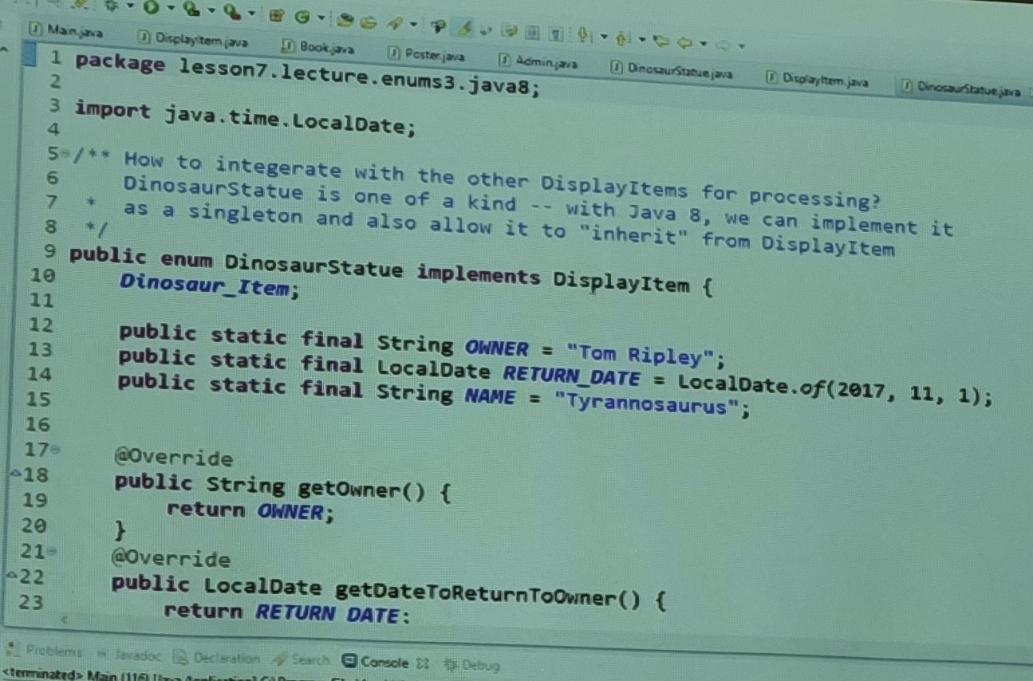

lesson7.lecture.iterator

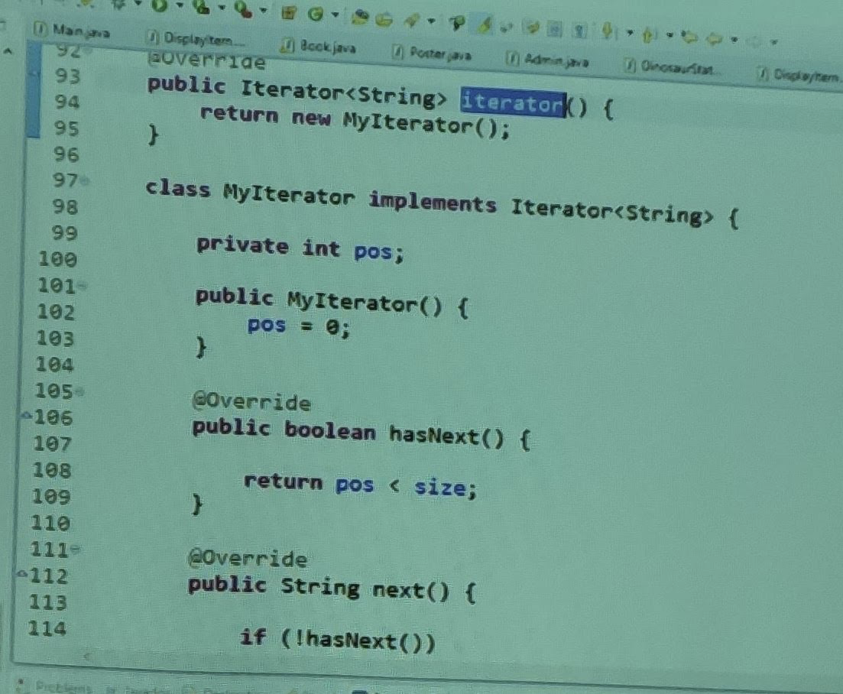

Exercise 7.3

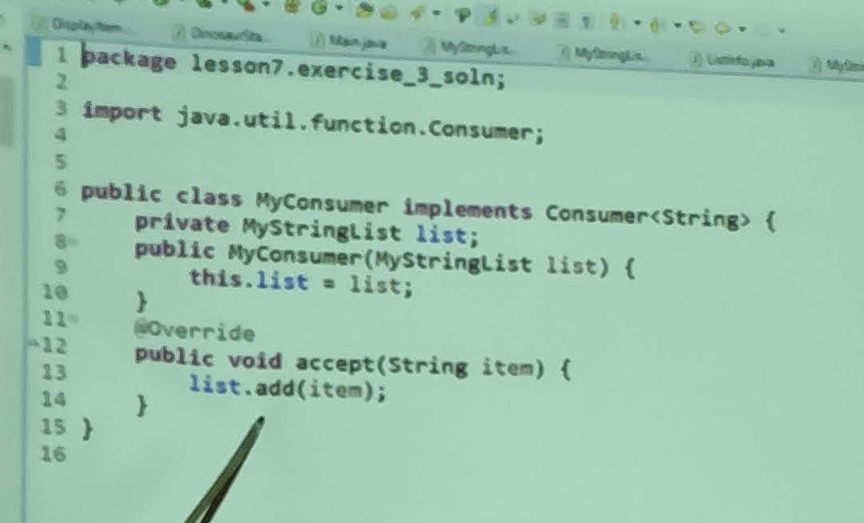

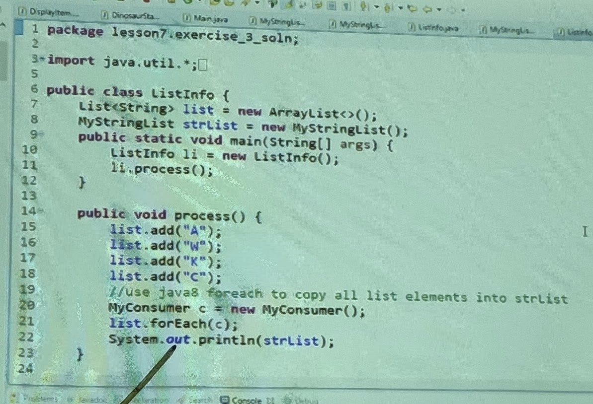

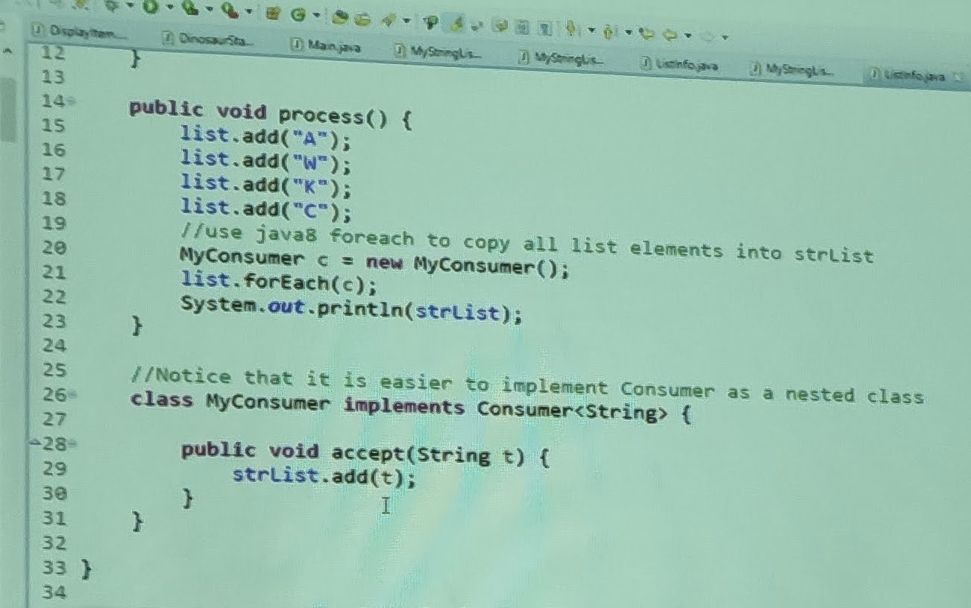

lesson7.lecture.hashcode.bad1

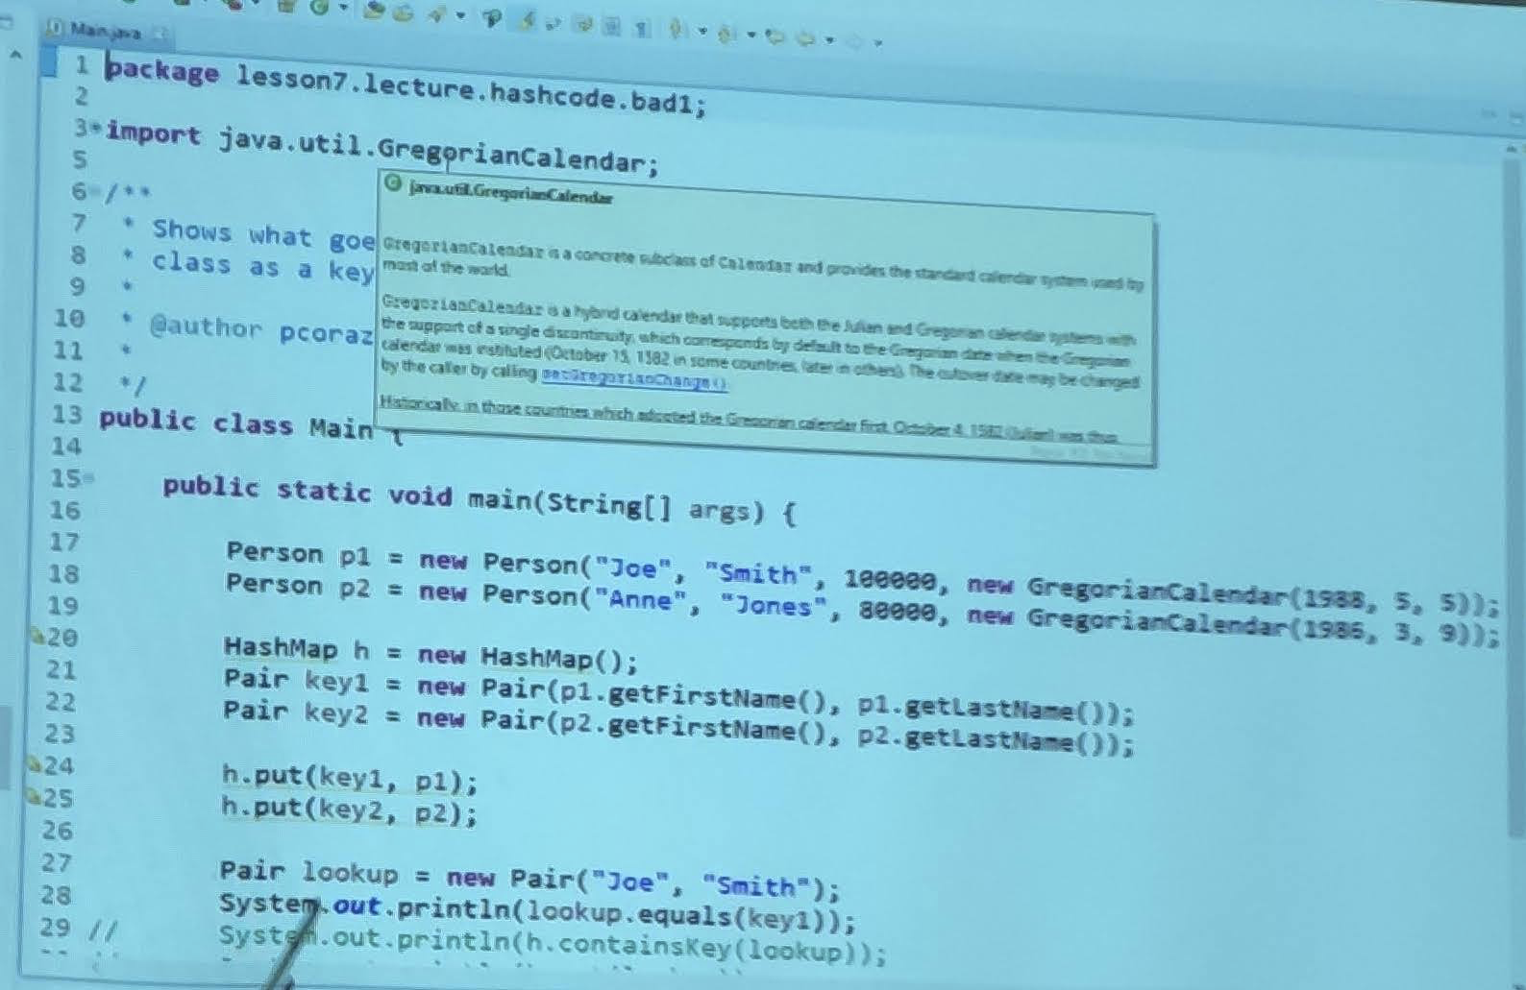

Lesson7.lecture.hashcode.bad2

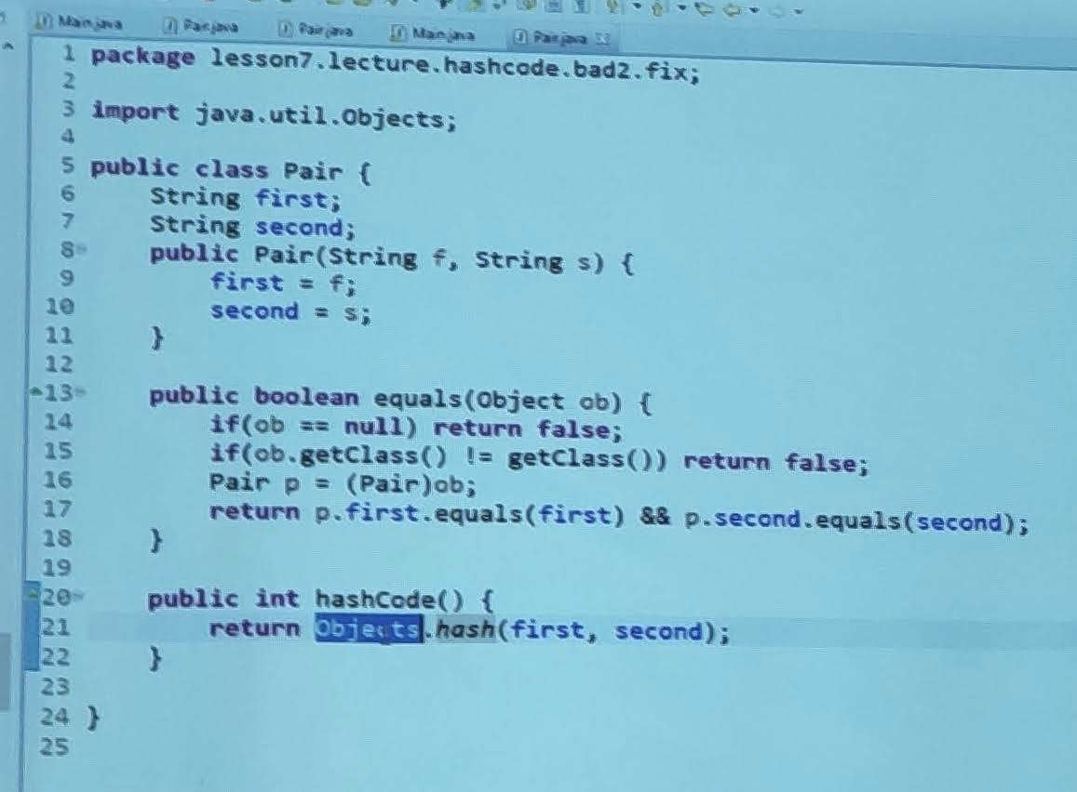

lesson7.lecture.hashcode.bad3

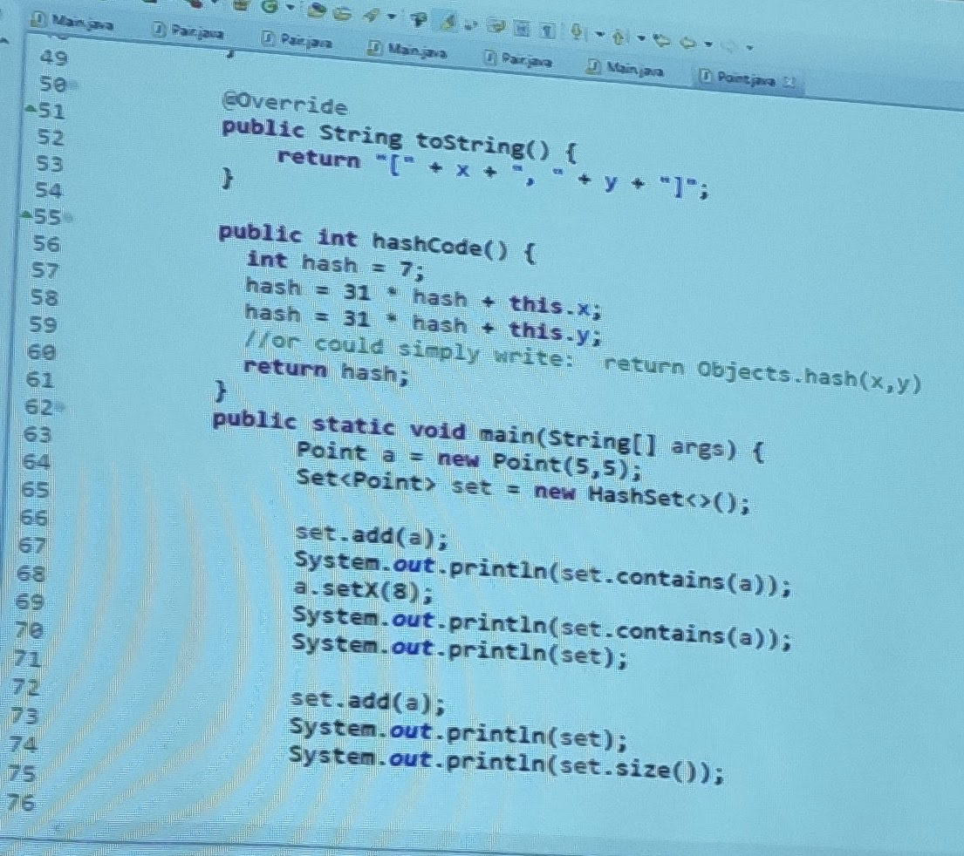

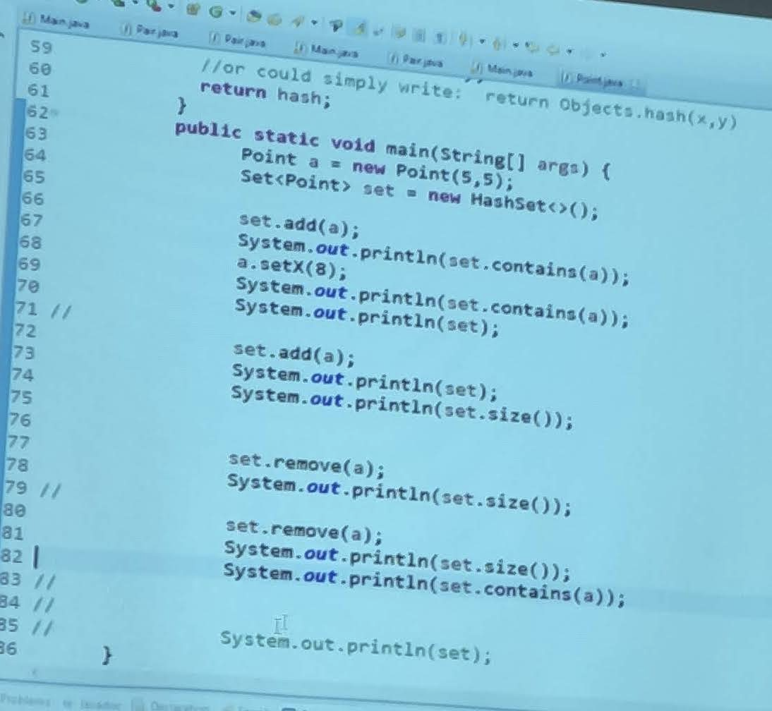

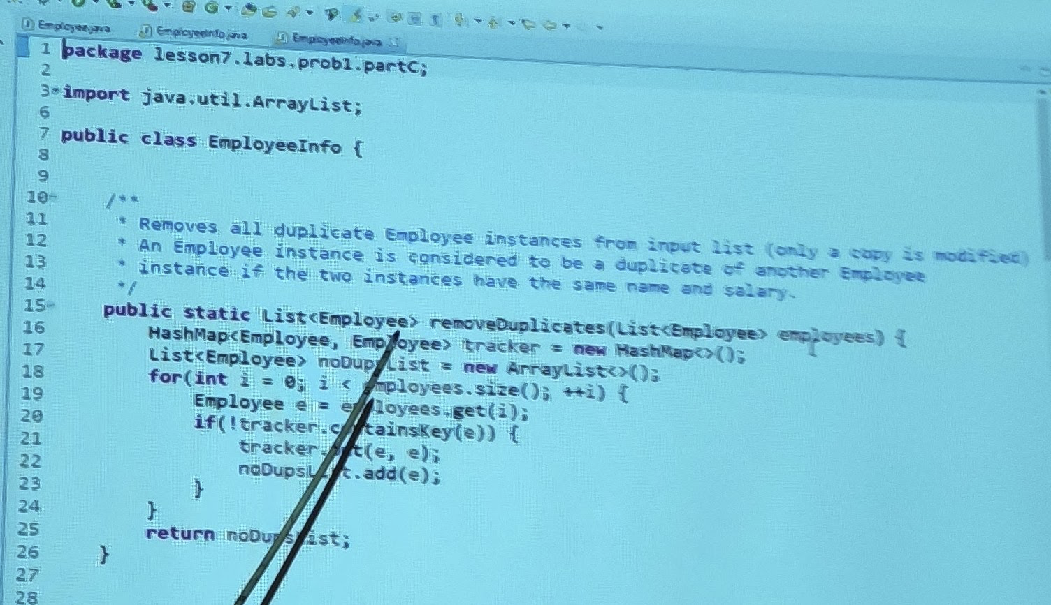

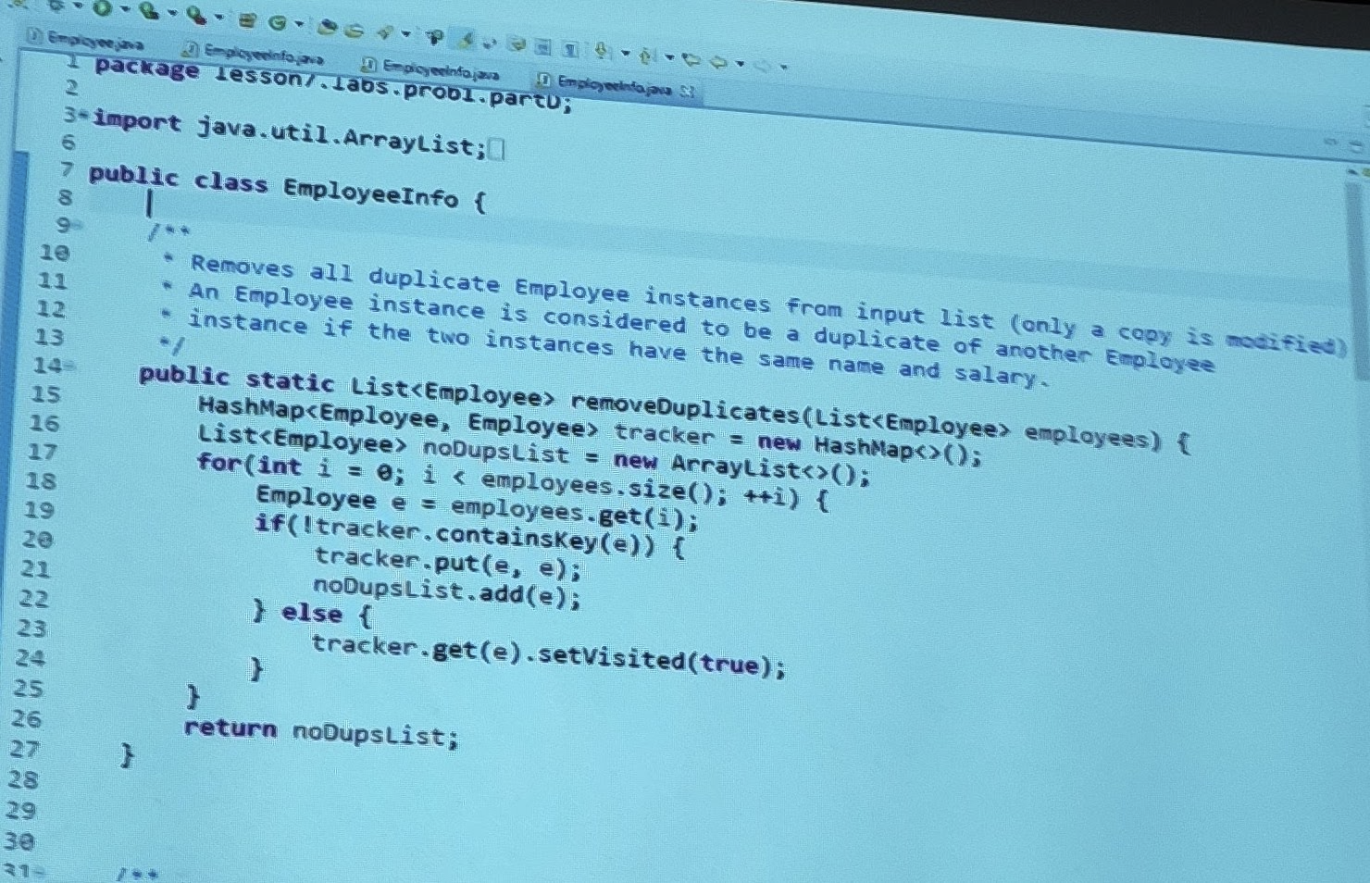

lesson8.lecture.functionalprogramming

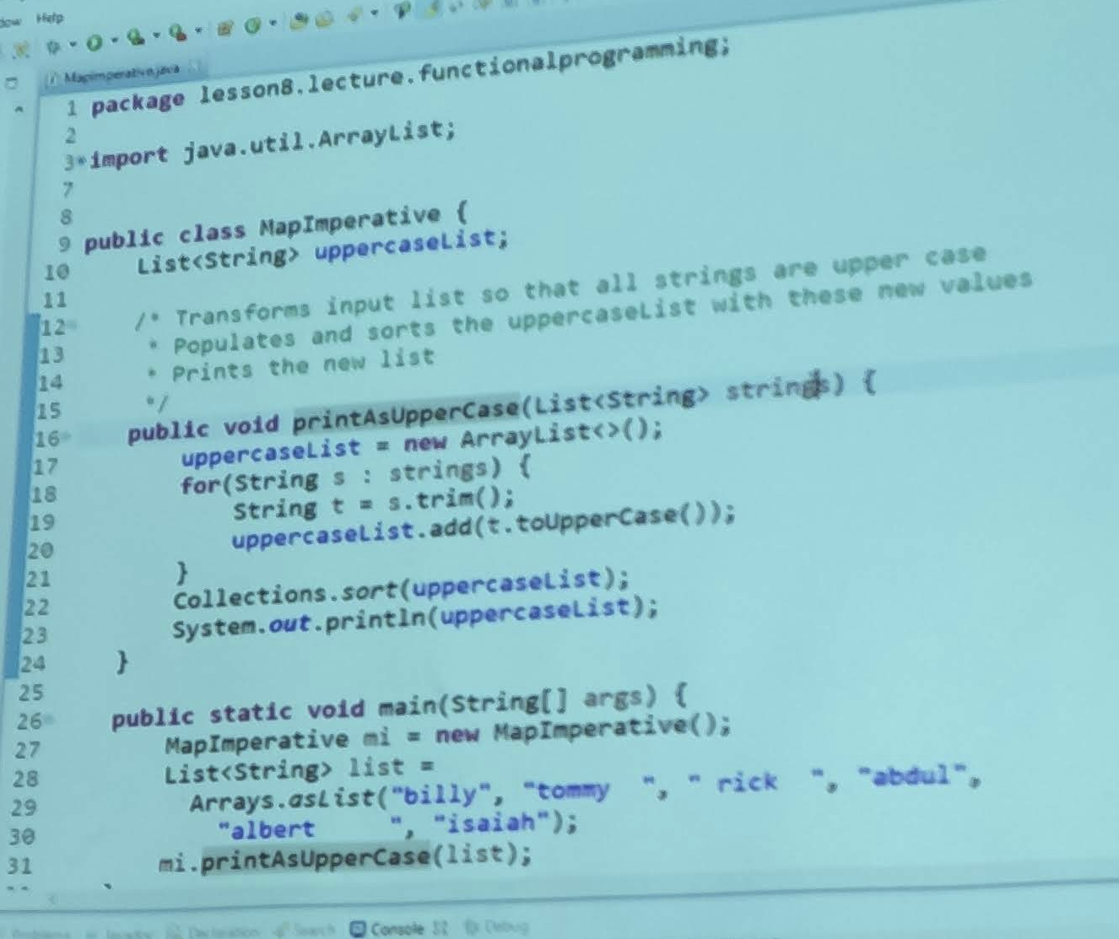

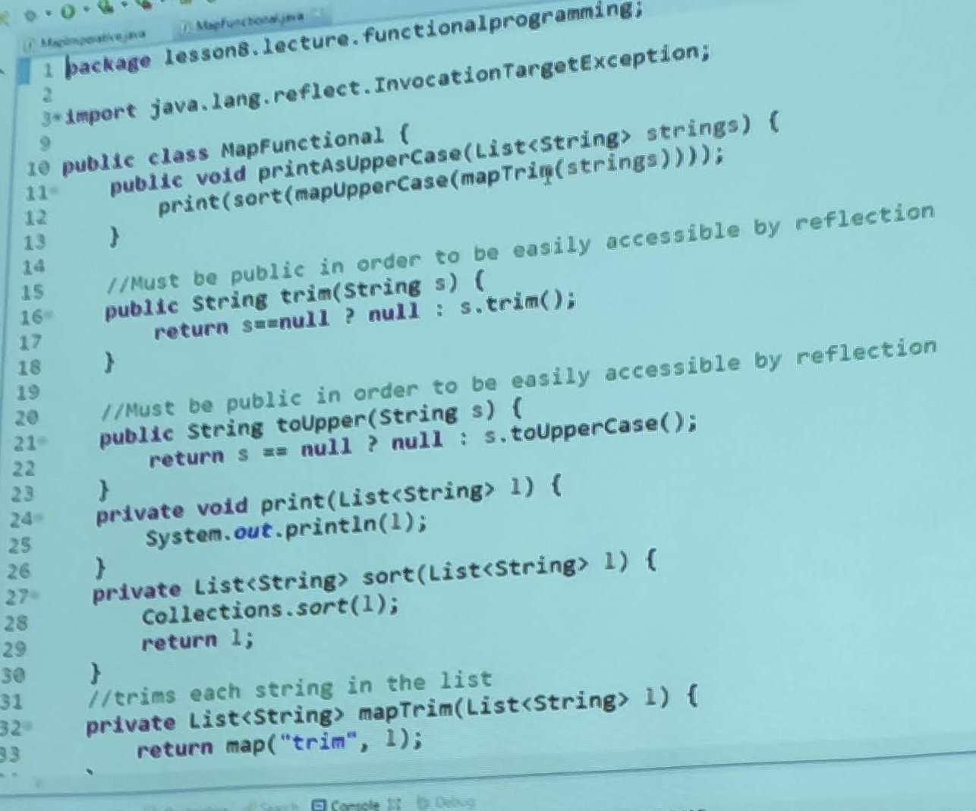

lesson8.lecture.methodreferences.objinstance.print

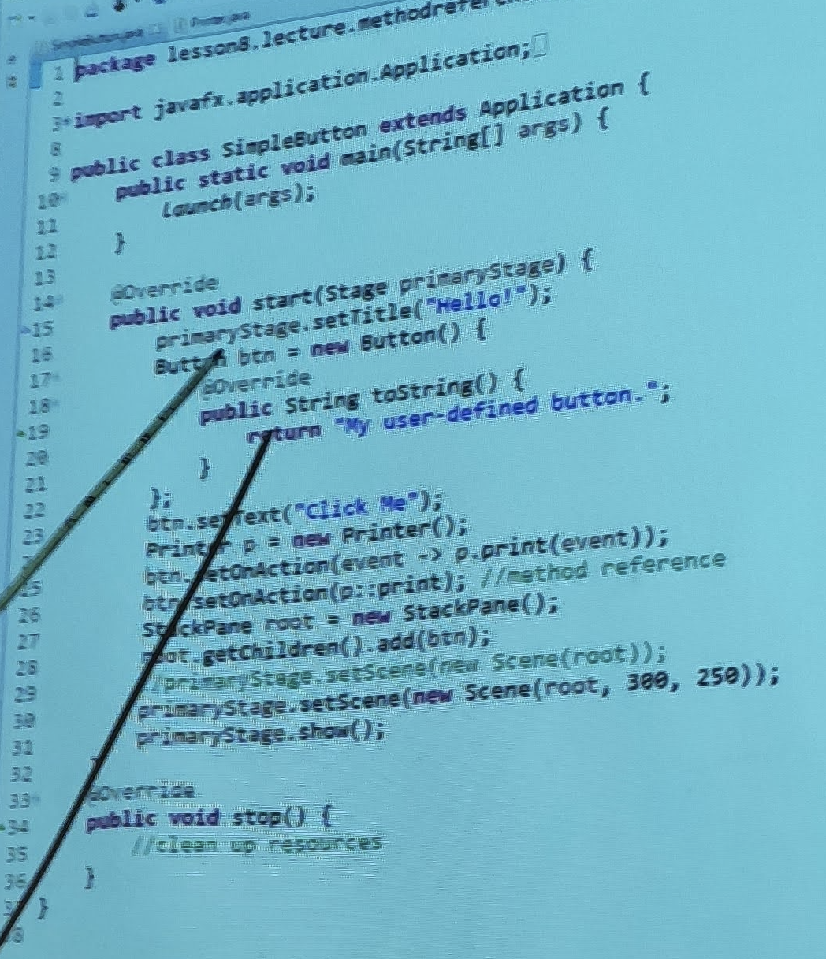

lesson9.lecture.lazystream.LoopFusion.java

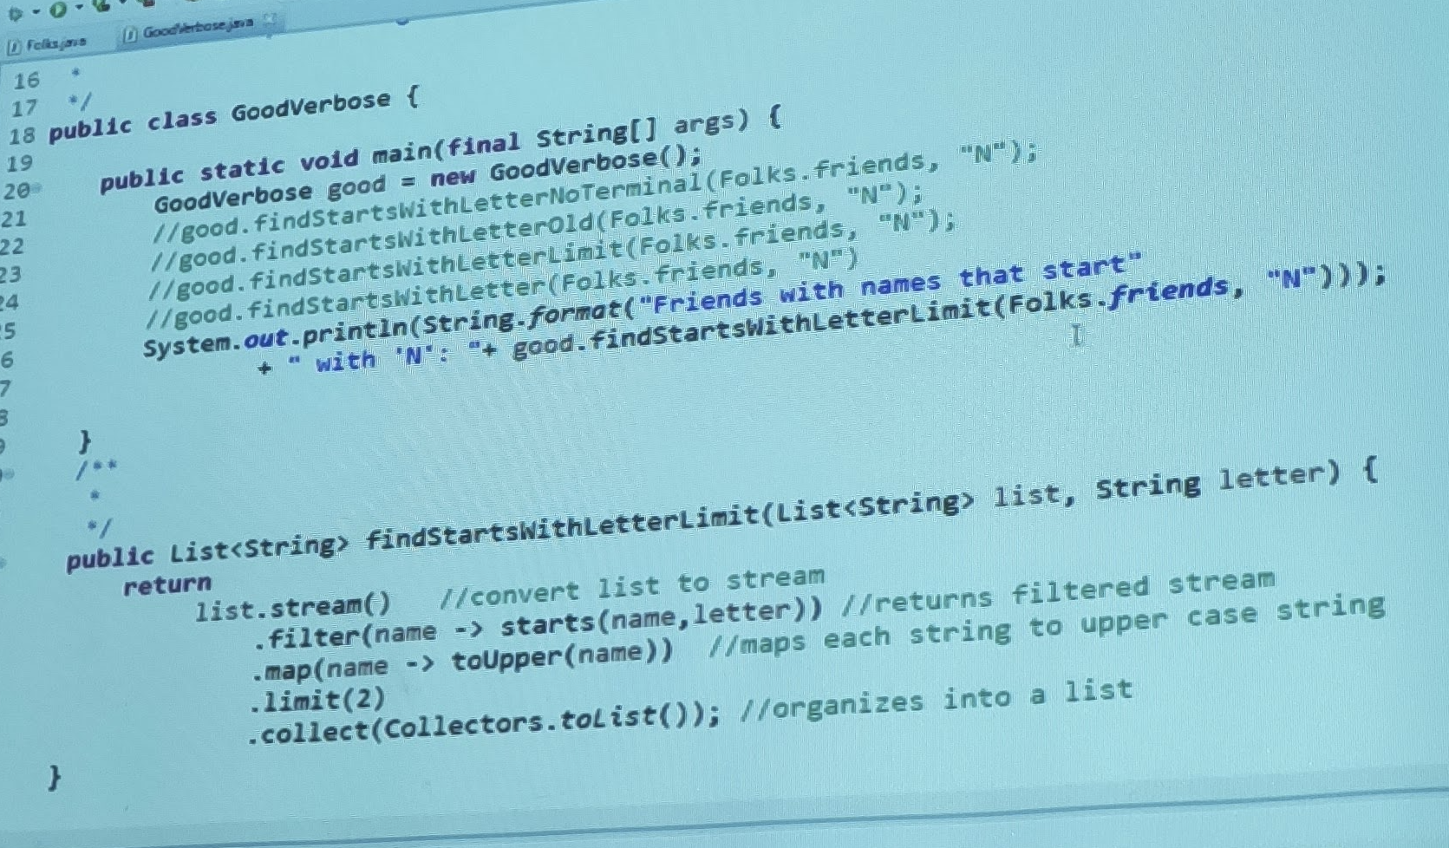

lesson9.lecture.iterate

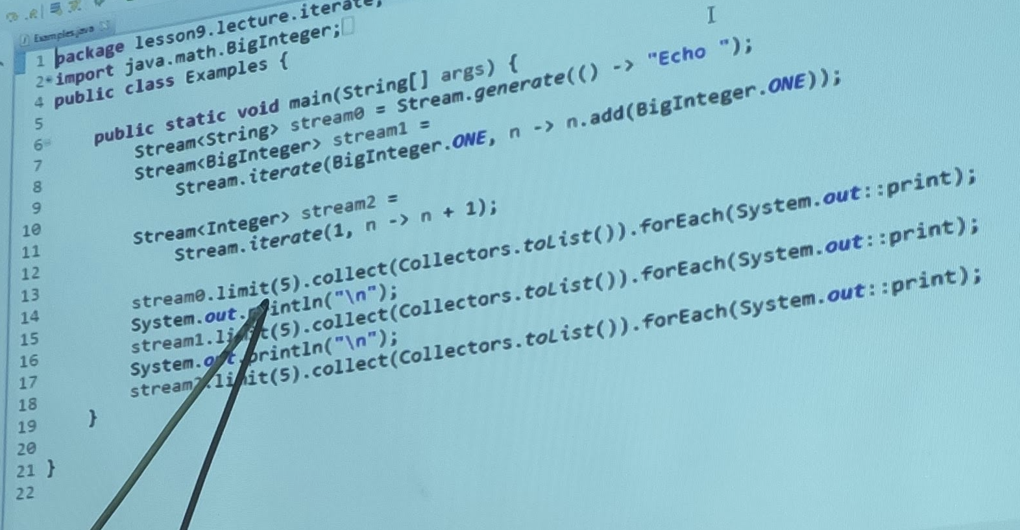

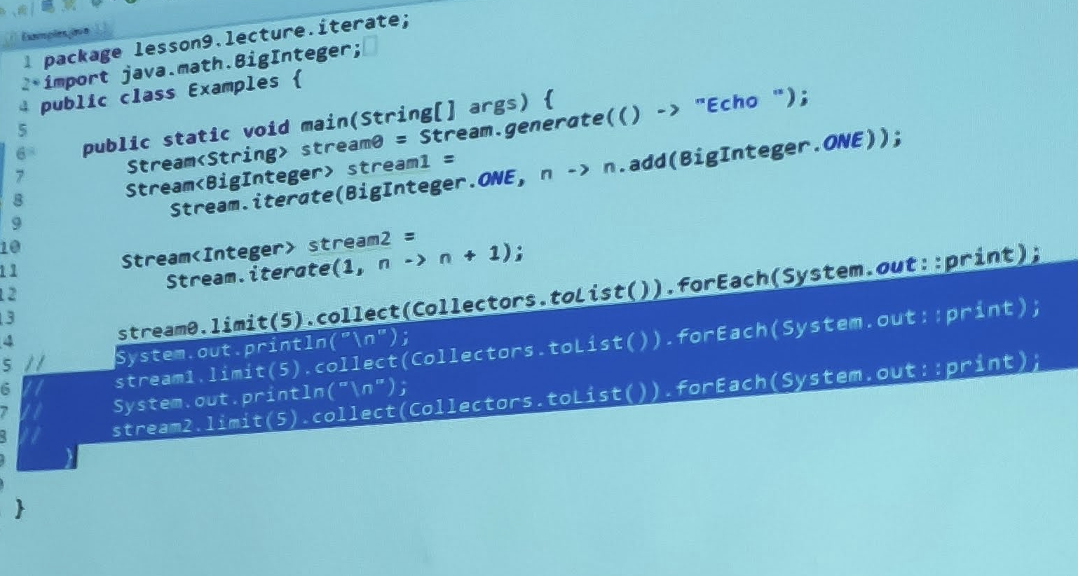

Exercise 9.3

